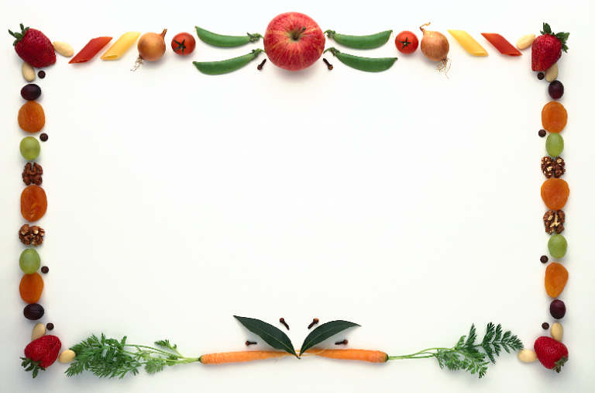

Dear Parent/Guardian: September 11, 2013

As you are aware, there has been an increase in “food allergies” in children. With your help, we are doing our best to make schools a healthy place for our children. In school age children, the majority of allergic reactions involve peanuts, tree nuts, eggs, milk and assorted fruits.

To ensure the food at Snack Time & classroom celebrations is as safe as possible we are asking your cooperation when sending in snacks/food. These are healthy alternatives that we would like your children to taste so they develop life long healthy choices. Please make sure snacks are portion control (small sizes) for preschool children. Birthday cakes & candy are not permitted.

If you wish to celebrate your child’s birthday at school please contact your child’s teacher. All celebrations will be during the class snack time
(15 minutes). Suggestions for snack and/or celebrations are:
1. Miniature muffins
2. Miniature cupcakes and doughnuts
3. sliced fruit or vegetable
4. Whole wheat & graham crackers
5. Low fat cheese
6. Yogurt & low fat frozen yogurt
7. Low fat pudding & Jell-O snacks
8. Rice crispy treats
9. Goldfish and pretzels

Do not hesitate to call the school Nurse or myself if you have any questions or concerns.

Bonita Potter-Brown
Principal

