

**Activity 3.1b Linear Measurement With US Customary Units Answer Key**

Introduction

The United States is the only developed country that does not use the International System of Units. The U S Customary units are the accepted units of measure. However, due to the global nature of the economy, SI units are also common. In order to participate in the global market, we must be able to understand and communicate using various measurement systems.

In this activity you will practice taking linear measurements using a standard ruler marked in US Customary units and correctly recording the measurements to reflect the precision of the measurement.

Equipment

* Engineering notebook
* Pencil
* Ruler – U S Customary
* PLTW Engineering Formula Sheet

Procedure

Record the length of each rectangle in both fractional inch and decimal inch forms. Record fractional inches to the nearest 1/32 of an inch, and record decimal inches to the nearest hundredth of an inch.

.

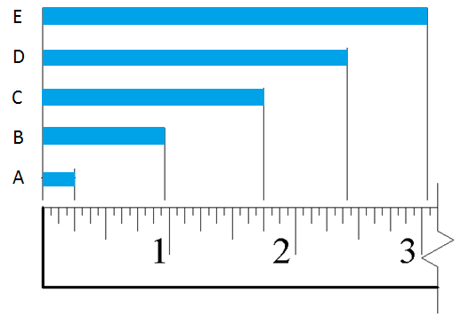

|  |  |  |  |
| --- | --- | --- | --- |
|  | Distance | Measurement (Fraction) | Measurement (Decimal) |
|  | A | **¼ in.** | **0.25 in.** |
|  | B | $\frac{31}{32}$**in.** | **0.97 in.** |
|  | C | **1 ¾ in.** | **1.75 in.** |
|  | D | $2 \frac{13}{32}$**in.** | **2.41 in.** |
|  | E | $3 \frac{1}{32}$**in.** | **3.10 in.** |

1. What is the difference in length between rectangles A and C?
$$\text{1}\frac{\text{3}}{\text{4}}\text{in.} \text{-} \frac{\text{1}}{\text{4}}\text{in.} \text{=} \text{1}\frac{\text{1}}{\text{2}}\text{ in.}$$

2. What is the difference in length between rectangles B and E?
$$\text{3}\frac{\text{1}}{\text{32}}\text{in. - }\frac{\text{31}}{\text{32}}\text{in. = 2}\frac{\text{1}}{\text{16}}\text{ in.}$$

3. Using a ruler displaying U S Customary units, measure the missing lengths in the figure below. In the top half of each box, enter the dimension in fractional inches to appropriate precision (nearest 1/32″). Then convert the length to decimal inches and enter the result into the bottom half of the corresponding box to the nearest hundredth of an inch. Be sure to include units. Note that ø indicates a diameter, and R indicates a radius.

Answers may be ± 1/32 in. from the measurement provided below.

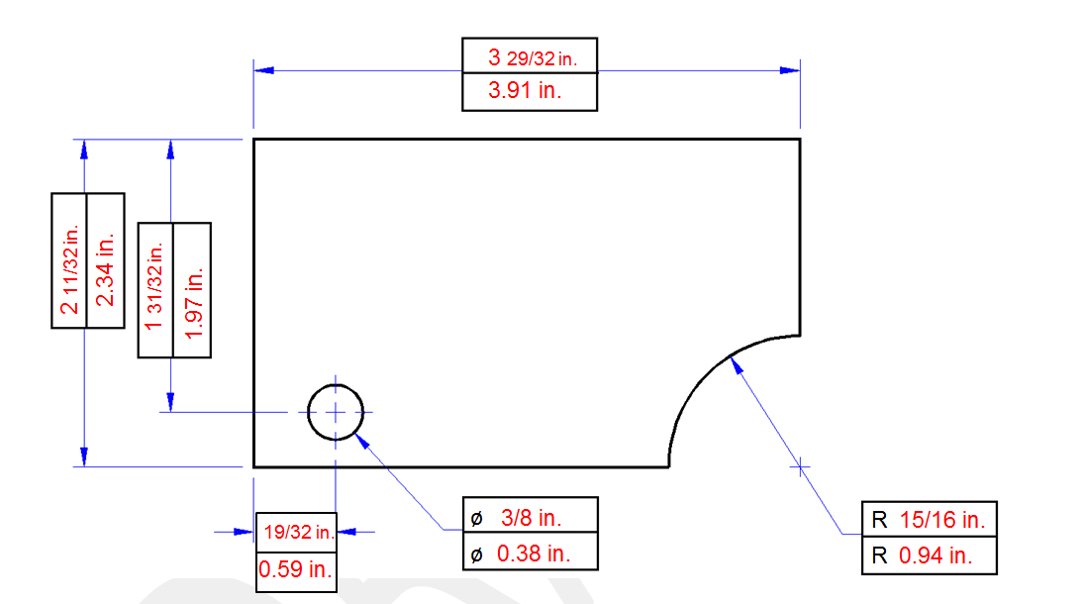

1. Measure the distance between two adjacent lines on a sheet of lined paper in both U S Customary and SI units. Record the measurements using each of the following units.

Fractional inches: Answers will vary [Decimal inches: Answers will vary]

1. Measure and record the length of additional items in your classroom using appropriate measurement units as directed by your instructor. Be sure to include the appropriate number of significant digits.

|  |  |  |  |
| --- | --- | --- | --- |
| Object | Description of measurement | Measurement units | Measurement |
| CD | Diameter | cm |  |
| Desk | Length and width | Decimal inches |  |
|  | Answers will vary |  |  |
|  |  |  |  |
|  |  |  |  |

1. In your engineering notebook, create a full scale isometric view of the object represented in the following sketch using the dimensions shown. Use a ruler to obtain the correct dimensions on your sketch.

C:\Users\dcalvin\Documents\IED2011\images\0blique4.tif

|  |  |
| --- | --- |
|  | The orientation of the sketch may vary; however, use a ruler to verify the correct dimensions. |
|  |  |

**Conclusion**

1. When you look at a drawing, how do you know if you are looking at U S Customary or SI measurements? Why is it important for an engineer to know this piece of information?

They have to tell the units of measurements on the drawing. Does it say inches or CM? Because if you don’t know the unit of measurement how are you going to build it. 3 miles is different than 3 mm.

2. What is the difference between precision and accuracy?

Precision (repeatability) = The degree to which repeated measurements show the same result

Accuracy = The degree of closeness of measurements of a quantity to the actual (or accepted) value

3. Is a measurement ever exact? Is there ever a measurement without an error?

No it is not there is always some error. Even if you think it is exactly 3 inches. It is not. 3.0000000000000000000000000000000000000000000…

1. On an inch ruler with increments of 1/16th of an inch what place should your round decimals to? What should you round fractions to?

Nearest hundredth in decimal, the nearest 1/32nd of an inch in fraction.