

**Activity 2.3 Glass Box Answer Key**

Introduction

Objects to be produced accurately often require more than a pictorial sketch. Multiview drawings provide an accurate representation of an object which can be used to create a physical object. Typically multiview drawings are used to show views of the faces of the object as if the viewer is looking directly at that face so that the line of sight is perpendicular to the face. This depicts the surface as the true size and shape.

The idea of orthogonal projections can be demonstrated using a glass box. Place an object in a glass box so that the faces of the object are parallel to the sides of the box. The features of each surface of the object can be projected onto a side of the glass box by drawing lines to indicate the object edges on the glass box surfaces.

In this activity you will design and build a box from a flat sheet of transparency film. You will then use your glass box to help you sketch orthogonal projections of an object and create multiview drawings.

Equipment

* Pencil
* Transparency print of Glass Box Pattern
* Wet-erase markers
* Puzzle cube pieces

Procedure

1. Draw the missing view.

|  |
| --- |
|  |

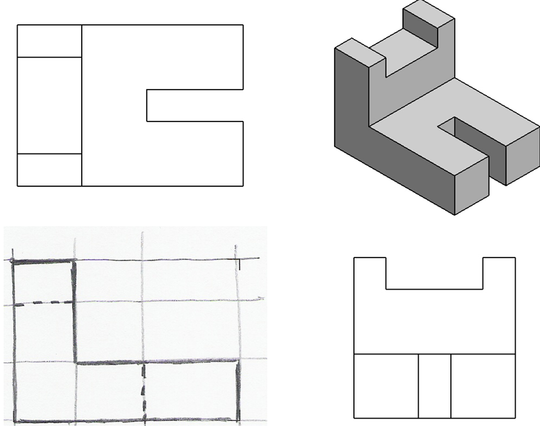

1. Draw the missing view.

|  |
| --- |
|  |

1. Draw the missing view.

|  |
| --- |
|  |

1. Draw the missing view.

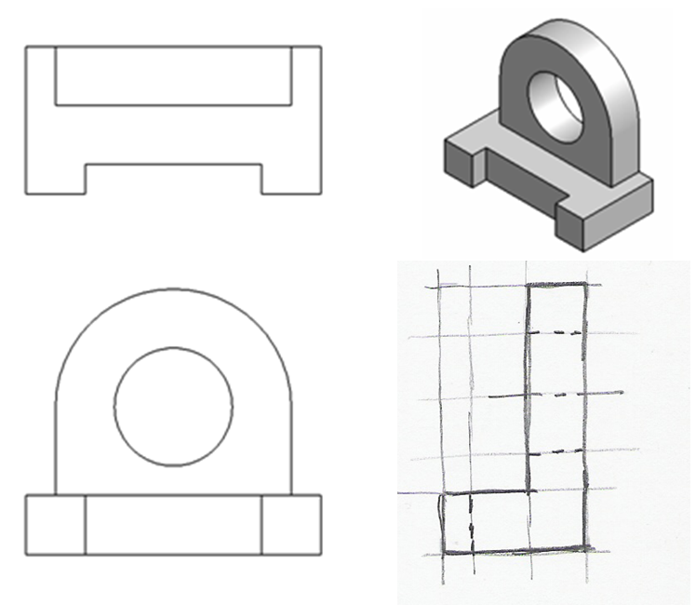

1. Draw the missing view.

|  |
| --- |
|  |

**Conclusion Questions**

1. What are two other names for a mutliveiw drawing?

Orthographic drawing or orthographic projection drawing

2. How many principal 2D views are there of any 3D object? Name the views.

Six view.

1. Front
2. Back (rear)
3. Bottom
4. Top
5. Left
6. right
7. What is a mutliview drawing? Why are they very important to engineers?

Shows two or more two-dimensional views of a three-dimensional object.

Provides the shape description of an object.

When combined with dimensions, serves as the main form of communication between designers and manufacturers

1. Which two dimensions (height, width, and/or length) can you see in the front view?

Which two dimensions can you see in the right view?

Which two dimensions can you see in the top view?

Front view – highlight and width

Right view – height and depth

Top view – width and depth

1. How do you select the front view of an object?
   * Most natural position or use
   * Shows best shape and characteristic contours
   * Longest dimensions
   * Fewest hidden lines
   * Most stable and natural position
2. What are hidden lines? What do they look like when drawn?

Hiddens lines are object lines that can not be seen from the cuurent view. They show detail that is not visable from that view. They are represented by medium weight dashed lines.

1. What are center lines used for? What do they look like when drawn?

Lines that define the center of arcs, circles, circular holes. Lines that define the axis of symmetry for parts with rotational symmetrical, such as cylinders and cones . A centermark look like bullseye and a center line is alternating small dashes and large dashes.