**PSI AP Physics I**

**Momentum Chapter Questions**

1. Which variable has more impact on an object’s motion? Its mass or its velocity?
2. Is momentum a vector or a scalar? Explain.
3. Why does changing the duration of an impulse on an object change the force exerted on the object so radically?
4. What is the value of air bags in cars and trucks?
5. What are the requirements for momentum to be conserved in a system?
6. If the momentum of an object is positive and decreasing, what does that tell you about the objects velocity? Describe the motion of the object.
7. You have done an experiment that measured the force applied to a block at different time intervals, and plotted a graph of Force vs. time. How would you find the impulse delivered by the force to the block? Once you find the impulse, what else can you determine?
8. If a constant non-zero force were applied to an object, would the impulse be affected? If, so how? If a non-constant force were applied to an object, would the impulse be affected? If so, how? Use real-world examples for support.
9. Why does a system slow down if the mass of the system increases? Why does a system speed up if the mass of the system is decreased? Use qualitative and quantitative data and real-world examples in your response.
10. Why is momentum only conserved in a closed system? What would an external force result in? Use real-world examples in your response.
11. Two balls of identical mass are thrown and strike each other mid air. If this is an elastic collision, how would the velocity of the balls be affected after the collision?
12. Consider an elastic and an inelastic collision. Discuss how the conservation of kinetic energy and the conservation of momentum apply to both.

**Chapter Problems**

1. **Momentum**

**Classwork**

1. What is the momentum of a 1400 kg car that is traveling eastward at 23 m/s?
2. A tricycle and its rider, with a combined mass of 34 kg have a momentum of -26 kg-m/s. What is the tricycle/rider system’s velocity?
3. What is the mass of a wagon whose momentum is 24 kg-m/s when its velocity is 2.2 m/s north?
4. What is the velocity of an 1800 kg truck whose momentum is 7200 kg-m/s?
5. A 5.0 kg object accelerates uniformly from rest for 5.0 s and reaches a final velocity of 20.0 m/s. At 3.0 s, what is the objects momentum?
6. A 2.0 kg rock is dropped from a height of 125 m. What is the momentum of the object just before it strikes the ground (Use g=10 m/s2)?

**Homework**

1. What is the momentum of a 3100 kg truck that is traveling south at 26 m/s?
2. A bicycle and its rider, with a combined mass 82 kg have a momentum of 380 kg-m/s. What is the bicycle/rider system’s velocity?
3. The record velocity for a hockey puck from an NHL player’s slapshot is 48.6 m/s. Find the mass of the hockey puck if its momentum is 8.03 kg-m/s.
4. A ball travels at 50 m/s. If the momentum of the object is 200 kg-m/s, what is the mass of the ball?
5. A 100 kg car accelerates uniformly from rest for a distance of 20 m in 10 s. What is the car’s momentum at time t = 5 s?
6. A 1.2 kg rock is thrown upwards with an initial velocity of 200 m/s. What is the momentum of the object at t = 20 s?
7. **Momentum Change and Impulse**

**Classwork**

1. An object with a momentum of 1500 kg-m/s directed east is acted upon by an impulse of 100.0 kg-m/s in the same direction. What is the final momentum of the object?
2. A 100 kg ball is initially traveling at 10 m/s. If the ball experiences a constant external force that increases the ball’s velocity to 15 m/s, what is the net impulse that acted on the ball?
3. An external force of 34.0 N acts on a system for 12.0 s in the negative x direction. What is the impulse delivered to the system?
4. How long must a 60 N net force act to produce a change in momentum of 240 kg-m/s?
5. How long was a 15 N force applied to an object if the net impulse delivered was 100.0 kg-m/s?
6. What was the net force on a truck if itsmomentum changed by 100.0 N-s in 6.0 s?
7. An object with a mass of 2 kg is accelerated from rest. The graph below shows the magnitude of the net force as a function of time. At t=4 s, what is the object’s velocity?

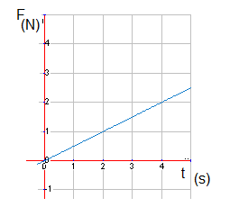

1. 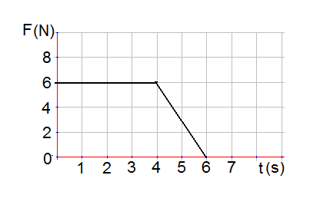An object of mass 3 kg starts from rest and moves along the x-axis as shown on the Force – time graph below. A net force is applied to the object in +x direction. What is the net impulse delivered by this force?

**Homework**

1. A soccer player kicks a ball with an average force of 1400 N over a contact time of 0.011 s. What is the impulse delivered to the soccer ball?
2. A 12 kg rock that is moving at 5.1 m/s in the +x direction experiences a net impulse of 98 N-m in the same direction. What is its final momentum?
3. What is the magnitude of an external force that changes an object’s impulse by 150 N-m in 5 s?
4. If a 5.0 kg object is dropped from a height of 60.0 m, what is the net impulse acting on the object after 2.0 s have passed (Use g = 10 m/s2)? What is the name of the force acting on the object?

Questions 25-26

A Force is applied to a 5.0 kg object over a period of time as shown below:

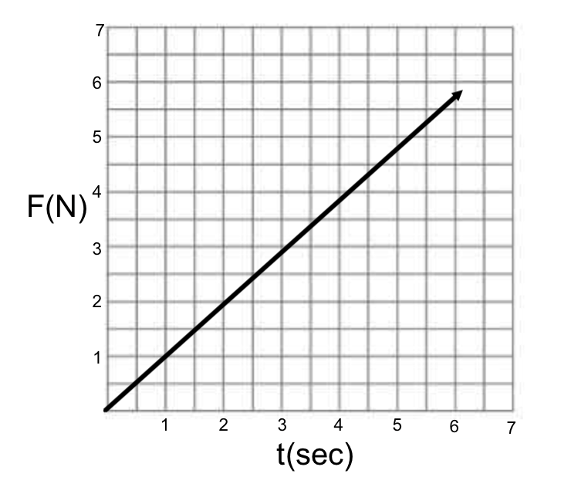

1. What is the net impulse on the object at t=2 s?
2. What is the change in velocity of the object at t=5 s?
3. **The Momentum of a System of Objects**

**Classwork**

1. Two objects in a system are moving as follows: Object 1 has a mass of 3.4 kg with a velocity of 11 m/s north, and Object 2 has a mass of 2.8 kg with a velocity of 15 m/s south. What is the momentum of the system?
2. Three objects in a system are moving as follows: Object 1 has a mass of 5.5 kg with a velocity of 12 m/s east; Object 2 has a mass of 2.2 kg with a velocity of 15 m/s west; and Object 3 has a mass of 8 kg with a velocity of 8 m/s west. What is the momentum of the system?
3. The net momentum of a system is 10.0 kg-m/s east. If two identical objects with a mass of 2.2 kg each in the system are moving in opposite directions, what is the difference of their velocities?
4. Three objects in a system are moving as follows: Two identical objects, each with a mass of 3.8 kg have a velocity of 5.1 m/s in the same direction, and a third object is moving at 2.0 m/s in the opposite direction. If the net momentum of the system is 0 kg-m/s, what is the mass of object 3?

**Homework**

1. Two objects in a system are moving as follows: Object 1 has a mass of 2.9 kg with a velocity of 8.7 m/s east, and Object 2 has a mass of 3.1 kg with a velocity of 12 m/s west. What is the momentum of the system?
2. Four objects are in a system and move as follows: Object 1 has a mass of 4.0 kg and a velocity of 5.0 m/s north; Object 2 has a mass of 5.0 kg and is moving at 4.2 m/s south; Object 3 has a mass of 7.0 kg and is moving with a velocity of 3.3 m/s south; and Object 4 has a mass of 9.0 kg and is moving with a velocity of 6.6 m/s south. What is the momentum of the system?
3. A system is described as follows: Object 1 has a mass of 5.0 kg and is moving with a velocity of 4.0 m/s north and Object 2 has a mass of 7.0 kg and is moving with a velocity of 8.0 m/s south. What is the force (magnitude and direction) required on Object 1 to change the net momentum to 0 kg-m/s in 5 s?
4. **Conservation of Momentum**

**Classwork**

1. A system of two objects has a momentum of 195 kg-m/s directed north. The objects strike each other and rebound with different velocities. If there is no friction (external force) acting on the two objects, what is their momentum after the collision?
2. An external force of 22 N is applied over a period of 6.1 s to a system that has an initial momentum of 224 kg-m/s. The force is in the same direction as the system’s velocity. Is momentum conserved? Why or why not? What is the momentum of this system at t = 6.1 s?

**Homework**

1. Three objects interact in a system that has a total initial momentum of 236 kg-m/s directed in the southeast direction. If there is no friction (external force) acting on the two objects, what is their momentum after 12 s?
2. A friction force acts on a skater of mass 52 kg with an initial velocity of 5.6 m/s, north. If her momentum after 3.2 s is 190 kg-m/s, what was the magnitude of the friction force?
3. **Conservation of Momentum in Collisions and Explosions**

**Classwork**

1. A 6.2 kg cannon ball is fired from a 280 kg cannon. The cannon recoils with a velocity of 4.9 m/s. What is the velocity of the cannon ball when it leaves the cannon?
2. A 42 kg surfer jumps off the back of a 22 kg surfboard that is moving forward with a velocity of 5.2 m/s. After the surfer leaves the surfboard, it moves forward with a velocity of 6.1 m/s. With what velocity did the surfer leave?
3. A 0.15 kg baseball reaches a batter with a speed of 32.0 m/s. If a 0.94 kg bat, moving with a speed of 41.0 m/s, hits the baseball, what is the speed of the baseball right after the elastic collision? Assume the bat speed does not change.
4. A 5.0 kg cart (cart 1) rolling at 5.0 m/s strikes another 5.0 kg cart (car 2) initially at rest. If the collision is elastic, what is the velocity of the first and second cart after the collision?
5. A 0.410 kgbilliard ball moving at 3.2 m/s strikes another billiard ball (elastic collision) with the same mass which was moving at 2.6 m/s in the same direction. What are the final velocities of the first and the second billiard balls?
6. Two friends are ice-skating and move towards each other with speeds of +2.3 m/s and -1.9 m/s, collide and stay holding each other. If both friends have the same mass of 30 kg, what is their final velocity?
7. Two carts of equal mass 1.2 kg collide. The velocity of cart 1 is 2.6 m/s. Cart 2’s initial velocity is -1.9 m/s. After the collision, cart 1 travels at -1.2 m/s. Is kinetic energy conserved during this collision? Why or why not?
8. A bowling ball moving with speed *v* collides head-on with a stationary tennis ball. The collision is elastic, and there is no friction. The bowling ball barely slows down. What is the speed of the tennis ball after the collision?
9. A cannon ball with a mass of 22 kg flies in horizontal direction with a speed of 50.0 m/s and strikes a railroad freight car filled with sand and initially at rest. The total mass of the car and sand is 25,600 kg. Find the speed of the car after the ball becomes embedded it the sand.
10. A 0.010 kg bullet is fired at a 0.50 kg block initially at rest. The bullet, moving with an initial speed of 100.0 m/s, emerges from the block with a speed of 75 m/s. What is the speed of the block after the collision?
11. A 50.0 kg boy jumps off the back of a 4.0 kg skateboard that is moving forward with an initial velocity of 3.0 m/s. Find the skateboard’s velocity immediately after the boy jumps if the boy’s velocity when jumping off the back is 2.5 m/s in the forward direction.

**Homework**

1. An archer of mass 90.0 kg shoots an arrow of mass 0.12 kg with an initial velocity of 73 m/s. What is the recoil velocity of the archer?
2. A 64 kg swimmer jumps, with a velocity of 4.2 m/s, off the front of a 25 kg kayak when the kayak is moving forward at a velocity of 3.2 m/s. What is the velocity of the kayak after the swimmer jumps off?
3. A small truck with mass, m collides elastically with a large car with the same mass that is initially at rest. If the truck is traveling with an initial speed v, what is the speed of the car, and the truck after the collision?
4. A 0.05 kg bullet is fired from a 2.0 kg gun. If the recoil velocity of the gun is 5.2m/s, what is the velocity of the bullet?
5. A 31 kg skateboarder is riding a 1.0 kg skateboard at a speed of 2.4 m/s. If he jumps off the board forward at a speed of 5 m/s, what is the speed of the skateboard once he leaves?
6. Two identical boats collide in the water. If the boats were traveling at the same speed at the moment of the collision, has the speed of the boats changed if the collision is elastic? Has the velocity changed? Explain.
7. A 22 kg go-cart traveling at 20.0 m/s north collides with a 24 kg go-cart traveling at 30.0 m/s in the opposite direction. If they collide and stick together, what is the velocity of the two go-cart system?
8. Two carts collide, however the velocities of both carts after the collision are 0 m/s. Is this possible? If so, how?
9. Ball 1 is traveling +3.3 m/s and collides elastically with ball 2 traveling at -2.2 m/s. If after the collision, ball 2 is traveling at +1.1 m/s, what is the velocity of ball 1?
10. A 5.0 kg ball shot at 20.0 m/s strikes a 2.0 kg ball initially at rest. If the velocity of the 2.0 kg ball after the collision is 5.5 m/s, what is the velocity of the 5.0 kg ball after the collision?
11. A 12,500 kg railroad freight car travels on a level track at a speed of 5.2 m/s. It collides and couples with a 22,600 kg second car, initially at rest and with brakes released. What is the speed of the two cars after collision?
12. When a ping-pong ball that is rolling with a velocity of +3.0 m/s, collides with a bowling ball at rest, what is the velocity of the ping-pong ball after the collision?
13. A rubber ball with a mass of 0.25 kg and a speed of 9.0 m/s collides perpendicularly with a wall and bounces off with a speed of 11 m/s in the opposite direction. What is the magnitude of the impulse acting on the rubber ball?
14. A 6.0 kg block moves with a constant speed of 5.0 m/s on a horizontal frictionless surface and collides elastically with an identical block initially at rest. The second block collides and sticks to the last 6.0 kg block initially at rest. What is the speed of the second 6.0 kg block after the first collision? What is the speed of the third 6.0 kg block after the second collision? Use the diagram below:

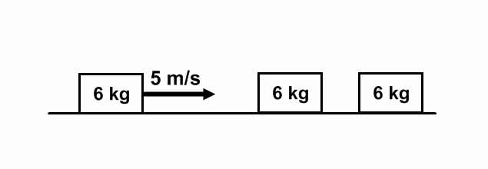

1. **Conservation of Momentum in Two Dimensions**

**Classwork**

1. A bowling ball with a momentum of 18 kg-m/s strikes a stationary bowling pin. After the collision, the ball has a momentum of 13 kg-m/s directed 550 to the left of its initial direction as shown below. What is the momentum (magnitude and direction) of the pin’s resultant motion?

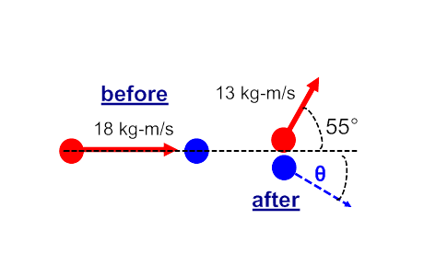

1. Object A of mass 19 kg travels to the east at 4.2 m/s and object B of mass 24 kg travels to the south at 3.6 m/s. They collide and stick together in a perfect inelastic collision as shown below. What is the magnitude and direction (with respect to the horizontal) of the velocity of the two objects after the collision?

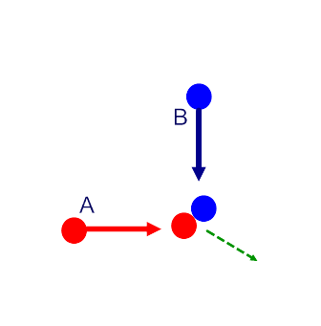

1. A lacrosse ball (m = 0.145 kg) is thrown against a vertical wall at angle, θ = 360, with a velocity of 38 m/s as shown below. Assume a perfectly elastic collision. What is the impulse delivered to the ball by the wall?

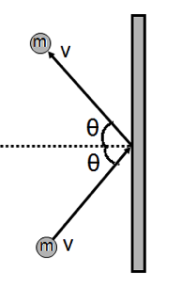

**Homework**

1. A bowling ball with a momentum of 15 kg-m/s strikes a stationary bowling pin. After the collision, the ball has a momentum of 11 kg-m/s directed 350 to the left of its initial direction as shown below. What is the momentum (magnitude and direction) of the pin’s resultant motion?

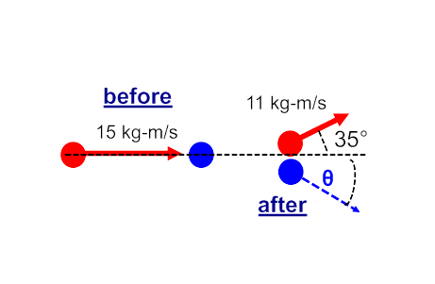

1. Object A of mass 8.1 kg travels to the east at 2.9 m/s and object B of mass 5.6 kg travels to the south at 1.2 m/s as shown below. They collide and stick together in a perfect inelastic collision. What is the magnitude and direction (with respect to the horizontal) of the velocity of the two objects after the collision?



1. Object A with mass 8.0 kg travels to the east at 10.0 m/s and object B with mass 3.0 kg travels south at 20.0 m/s. The two objects collide and stick together as shown below. What is the magnitude of the velocity they have after the collision? What is the direction of the velocity they have after the collision?



1. **General Problems**

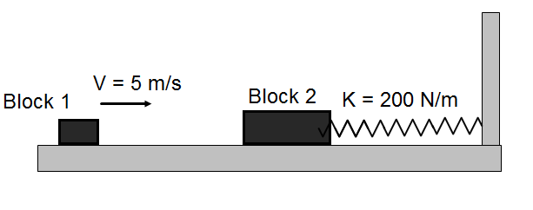

1. Block 1 with a mass of 0.509 kg moves at a constant speed of 5.00 m/s on a horizontal frictionless track and collides and sticks to a stationary block 2 mass of 1.50 kg. Block 2 is attached to an unstretched spring with a spring constant 200.0 N/m.
2. Determine the momentum of block 1 before the collision.
3. Determine the kinetic energy of block 1 before the collision.
4. Determine the momentum of the system of two blocks after the collision.
5. Determine the velocity of the system of two blocks after the collision.
6. Determine the kinetic energy of the system two blocks after the collision.
7. Determine the maximum compression in the spring after the collision.

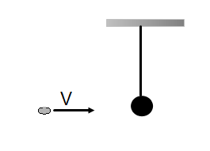

1. A 20.0 g piece of clay moves with a constant speed of 15.0 m/s. The piece of clay collides and sticks to a massive ball of mass 0.900 kg suspended at the end of a string.
2. Calculate the momentum of the piece of clay before the collision.
3. Calculate the kinetic energy of the piece of clay before the collision.
4. What is the momentum of two objects after the collision?
5. Calculate the velocity of the combination of two objects after the collision.
6. Calculate the kinetic energy of the combination of two objects after the collision.
7. Calculate the change in kinetic energy during the collision.
8. Calculate the maximum vertical height of the combination of two objects after the collision.

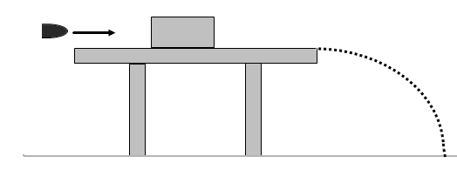

1. A 10.0 g bullet moves at a constant speed of 500.0 m/s and collides with a 1.50 kg wooden block initially at rest. The surface of the table is frictionless and 70.0 cm above the floor level. After the collision the bullet becomes embedded into the block. The bullet-block system slides off the top of the table and strikes the floor.
2. Find the momentum of the bullet before the collision.
3. Find the kinetic energy of the bullet before the collision.
4. Find the velocity of the bullet-block system after the collision.
5. Find the kinetic energy of the bullet-block after the collision.
6. Find the change in kinetic energy during the collision.
7. How much time it takes the bullet-block system to reach the floor?
8. Find the maximum horizontal distance between the table and the striking point on the floor.

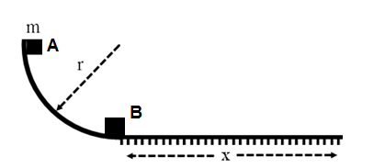

1. Block A with a mass of m is released from the top of the curved track of radius r. Block A slides down the track without friction and collides inelastically with an identical block B initially at rest. After the collision the two blocks move distance X to the right on the rough horizontal part of the track with a coefficient of kinetic friction µ.
2. What is the speed of block A just before it hits block B?
3. What is the speed of the system of two blocks after the collision?
4. What is the kinetic energy of the system of two blocks after the collision?
5. How much energy is lost due to the collision?
6. What is the stopping distance x of the system of two blocks?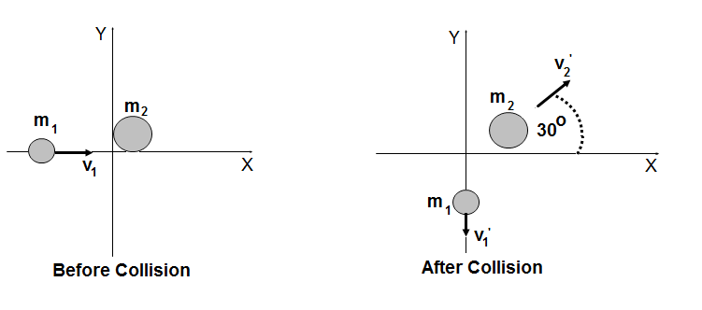
7. Two discs of masses m1 = 2.0 kg and m2 = 8.0 kg are placed on a horizontal frictionless surface. Disc m1 moves at a constant speed of 8.0 m/s in +x direction and disc m2 is initially at rest. The collision of two discs is perfectly elastic and the directions of two velocities presented by the diagram.
8. What is the x- component of the initial momentum of disc m1?
9. What is the y- component of the initial momentum of disc m1?
10. What is the x- component of the initial momentum of disc m2?
11. What is the y- component of the initial momentum of disc m2?
12. What is the x- component of the final momentum of disc m1?
13. What is the x-component of the final momentum of disc m2?
14. What is the y-component of the final momentum of disc m2?
15. What is the final vector velocity of m2?
16. What is the y-component of the final momentum of disc m1?
17. What is the final vector velocity of disc m1?

**Answers**

**Chapter Questions**

1. They both have the same impact as momentum is linearly dependent on the mass and the velocity.
2. Momentum is equal to the product of the mass and the velocity of an object. Mass is a scalar, but velocity is a vector – it has magnitude and direction. A scalar times a vector is a vector. So, momentum is a vector, with magnitude and direction.
3. For a given impulse, the force is inversely proportional to the duration of the impulse’s application. The y value in an inverse function (y=1/x) decreases very rapidly as x increases. Since F=I/Δt, as Δt increases, F decreases very rapidly.
4. The impulse delivered to a passenger in a vehicle equals the change in momentum of the car when it has a rapid decrease in velocity (such as a crash). Thus, the impulse is fixed depending on the car’s mass and the initial and final velocities (final velocity is zero in a crash). But, you can minimize the force delivered to the passengers by extending the time of the collision. The air bag inflates and allows a longer time for the passenger to come to rest – Δt increases, so F decreases. A smaller force on the passengers results in less bodily harm.
5. The system must be a closed one – there is no movement of objects in or out. And, the only way the momentum of a closed system can be changed is by the application of an external force. The force, acting over a period of time delivers an impulse to the system.
6. The object’s velocity is decreasing, which means it has a negative acceleration. If the friction force is providing the negative acceleration, the object will eventually come to a stop. If it is another constant external force (someone is pushing it), then the object will come to a stop, then increase its velocity in the opposite direction.
7. For the time interval to be solved for, take the area under the curve on the graph described by the Force applied vs. time. Once you have the impulse, you have also found the change in momentum of the block.
8. A constant force results in a constant acceleration of the object and an impulse that grows linearly with time. A non constant force gives a non constant acceleration and an impulse that depends on how the force varies. It is no longer linear. An example of a constant force is the force due to gravity. An example of a non constant force is a bat hitting a baseball – the force, and impulse starts at zero, increases quickly to a maximum value, and then decreases very quickly to zero.
9. The momentum equation, p=mv, tells it all quantitatively. From this, momentum and mass are directly proportional; momentum and velocity are directly proportional; and mass and velocity are inversely proportional. Therefore, if mass increases, momentum increases, and vice versa – assuming velocity is held constant. If the mass of an object increases, the momentum increases. However, objects usually do not stay at the same speed when masses are added, however if they do, the momentum increases. A real world example of this scenario is adding mass to a truck. Assume the truck can move 60 mph with no added mass, or a ton of added mass. When it has no added mass, it has one value of momentum. When it moves with the same speed and a greater mass, it will have a greater momentum.
10. If a system is open, then other objects can cross the system boundary and bring in external momentum, which will change the initial momentum of the system. If a system is closed, any forces between the objects within the system will net to a zero force (zero impulse) due to Newton’s Third Law. An external force on a closed system will increase the momentum of the closed system as described by the impulse-momentum equation. A system of a child on a wagon that is rolling along a concrete surface will experience an external friction force that will apply a negative impulse, decreasing the momentum of the system.
11. The balls would exchange velocities. They would move in opposite directions.
12. Momentum is conserved in both types of collision. Kinetic Energy is only conserved in an elastic collision.

**Chapter Problems**

1. 32,000 kg-m/s, east
2. -0.76 m/s
3. 11 kg
4. 4.0 m/s
5. 60 kg-m/s
6. 100 kg-m/s
7. 81,000 kg-m/s, south
8. 4.6 m/s
9. 0.17 kg
10. 4 kg
11. 200 kg-m/s
12. 0 kg-m/s
13. 1600 kg-m/s, east
14. 500 N-m
15. -408 kg-m/s
16. 4 s
17. 6.7 s
18. 17 N
19. 2 m/s
20. 30 kg-m/s
21. 15 kg-m/s
22. 160 kg-m/s
23. 30 N
24. 100 N-s; gravitational force
25. 2 N-m
26. 2.5 m/s
27. 4.6 kg-m/s, south
28. 31 kg-m/s, west
29. 4.6 m/s
30. 19 kg
31. 12 kg-m/s, west
32. 84 kg-m/s, south
33. 7.2 N, north
34. 195 kg-m/s south
35. No, there is an external force; 360 kg-m/s
36. 236 kg-m/s, southeast
37. 32 N; south
38. 220 m/s
39. 4.7 m/s
40. 49 m/s
41. 0 m/s, 5.0 m/s
42. 2.6 m/s, 3.2 m/s
43. +0.2 m/s
44. Kinetic energy is not conserved, since this is not an elastic collision. If it were, then the carts would exchange velocities, and cart 1 would have a velocity of -1.2 m/s which is less than -1.9 m/s – hence, this is an inelastic collision and some of the kinetic energy was transformed into other forms of energy such as thermal and sound.
45. 2v
46. 0.043 m/s
47. 0.53 m/s
48. 9.3 m/s
49. 0.97 m/s
50. 0.64 m/s
51. v; 0 m/s
52. 210 m/s
53. -7.1m/s
54. No, the speeds remain the same, but their velocities change. Elastic collisions between objects with the same mass traveling at the same speed results in the two masses exchanging velocities.
55. 6.1 m/s south
56. Yes, if the momentum of both carts before the collision is equal in magnitude, yet opposite in direction.
57. -4.4 m/s
58. 18 m/s
59. 1.9 m/s
60. -3 m/s
61. 0.50 N-m
62. 5.0m/s; 2.5 m/s
63. 15 kg-m/s; -45º
64. 2.7 m/s; -47º
65. 8.9 N-m
66. 8.7 kg-m/s; -46º
67. 1.8 m/s; -16º
68. 9.1 m/s; -37º

**General**

69.

a. 2.5 kg m/s

b. 6.25 J

c. 2.5 kg m/s

d. 1.25 m/s

e. 1.56 J

f. 0.12 m

70.

a. 0.3 kg m/s

b. 2.25 J

c. 0.3 kg m/s

d. 0.33 m/s

e. 0.05 J

f. -2.2 J

g. 0.006 m

71.

a. 5 kg m/s

b. 1250 J

c. 3.3 m/s

d. 8.2 J

e. -1240 J

f. 0.38 s

g. 1.25 m

72.

a. (2gr)1/2

b. (2gr)1/2/2

c. grm/2

d. –mgr/2 (half is lost)

e. r/4μ

73.

a. 16 kg m/s

b. 0

c. 0

d. 0

e. 0

f. 16 kg m/s

g. 9.2 kg m/s

h. 2.3 m/s

i. -9.2 kg m/s

j. 4.6 m/s