*PSI AP Physics 1*

**Kinematics**

Multiple-Choice Questions

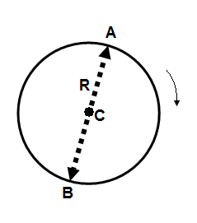

1. An object moves around a circular path of radius R. The object starts from point A, goes to point B and describes an arc of half of the circle. Which of the following is true about the magnitude of displacement and traveled distance?

Displacement Traveled Distance

A. R 2 $π$ R

B. 2R πR

C. $\frac{R}{2}$ R

D. R 4πR

1. A rock is thrown straight up from the edge of a cliff. The rock reaches the maximum height of 15 m above the edge and then falls down to the bottom of the cliff 35 m below the cliff. What is the traveled distance of the rock?

A. 30 m B. 35 m C. 50 m D. 65 m

1. A rock is thrown straight up from the edge of a cliff. The rock reaches the maximum height of 15 m above the edge and then falls down to the bottom of the cliff 35 m below the cliff. What is the displacement of the rock?

A. 15 m B. 35 m C. 50 m D. 65 m

1. Can an object’s average velocity equal zero when object’s speed is greater than zero?

A. Yes, when the object moves in a straight line at a constant rate

B. Yes, when the object returns to its original position

C. No, it is impossible because they are always equal

D. No, it is impossible because the magnitude of the velocity is always greater that speed

1. A car accelerates from rest at a constant rate 5 m/s2. Which of the following statements is true?

A. The car travels 5 m in every second

B. The car decreases its velocity 5 m/s in every second

C. The car increases its velocity 5 m/s in every second

D. The car’s velocity doesn’t change

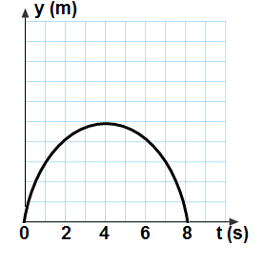An object is thrown straight up with an initial velocity v0. The graph represents the object’s vertical displacement as a function of time. Use the graph to the right for questions 6 through 8.

1. What is the total flying time of the object?

A. 2 s B. 4 s C. 6 s D. 8 s

1. At what time the object reaches its maximum height?

A. 2 s B. 4 s C. 6 s D. 8 s

1. What is the initial velocity v0 of the object?

A. 20 m/s B. 40 m/s C. 80 m/s D. 50 m/s

1. 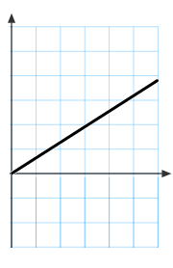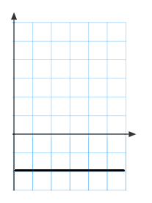Which of the following graphs represents the velocity as a function of time of an object thrown straight up?

A. B.

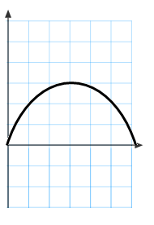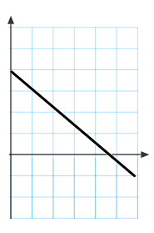

C. D.

1. Which of the following graphs represents the acceleration as a function of time of an object thrown straight up?

A. B.



C. D.

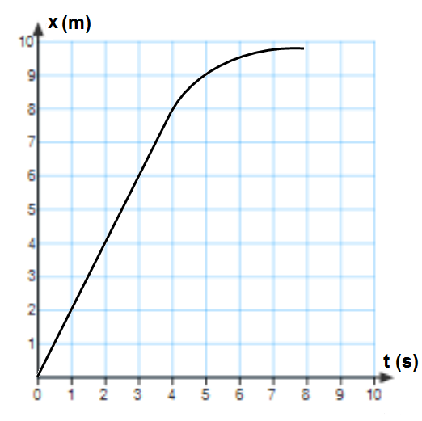The relationship between the position and time of a moving object is shown on the graph. Use this graph for questions 11 and 12.

1. What is the instantaneous speed of the object at 4 s?

A. 1 m/s B. 2 m/s C. 3 m/s D. 4 m/s

1. During which of the following times does the object accelerate?

A. 0 s to 2 s B. 2 s to 4 s C. 0 s to 4 s D. 4 s to 8 s

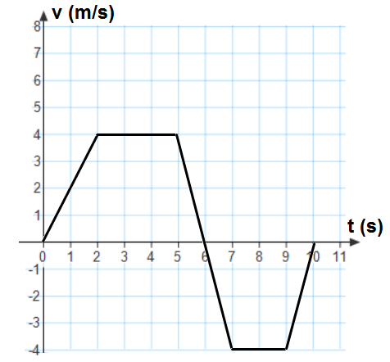The graph to the right describes the relationship between velocity and time for a moving object. Use this graph for questions 13 through 18.

1. What is the acceleration at time t = 1 s?

A. 4 m/s2 B. 2 m/s2 C. -2 m/s2

D. -4 m/s2

1. What is the acceleration at time t = 8 s?

A. 4 m/s2 B. -2 m/s2

C. -4 m/s2 D. 0 m/s2

1. What is the acceleration at time t = 6 s?

A. 1 m/s2 B. 2 m/s2

C. -4 m/s2 D. 0 m/s2

1. What is the total displacement for the entire trip?

A. 18 m B. 12 m C. 6 m D. 30 m

1. What is the total traveled distance for the entire trip?

A. 18 m B. 12 m C. 6 m D. 30 m

1. Between what times does the object approach the origin at the constant speed?

A. 2 s to 5 s B. 6 s to 7 s C. 7 s to 9 s D. 9 s to 10 s

1. A rock is thrown straight up with twice the initial velocity of another. How much higher will the first rock be at its apex?

A. 2 times B. 4 times C. 16 times D. The rocks will reach the same apex point

1. A student drops a pebble from the edge of a vertical cliff. The pebble hits the ground 4 s after it was dropped. What is the speed of the pebble just before it hits the ground?

A. 20 m/s B. 40 m/s C. 60 m/s D. 80 m/s

1. A student drops a pebble from the edge of a vertical cliff. The pebble hits the ground 4 s after it was dropped. What is the height of the cliff?

A. 20 m B. 40 m C. 60 m D. 80 m

1. An Astronaut on the Moon simultaneously drops a bird feather and a screw driver. The fact that two objects reach the surface at the same time can be explained by which of the following?

A. The Moon has no gravity

B. The Moon’s gravity is much weaker than the Earth’s gravity

C. The same gravitational force is applied on both objects on the Moon

D. At the given location all objects fall with the same acceleration in the absence of air resistance

1. A marble launcher shoots a marble horizontally from the height of 0.2 m above a horizontal floor. The marble lands on the floor 5 m away from the launcher. How long did the marble stay in the air?

A. 0.1 s B. 0.2 s C. 0.3 s D. 0.4 s

1. A marble launcher shoots a marble horizontally from the height of 0.2 m above a horizontal floor. The marble lands on the floor 5 m away from the launcher. What is the initial speed of the marble?

A. 5 m/s B. 10 m/s C. 15 m/s D. 25 m/s

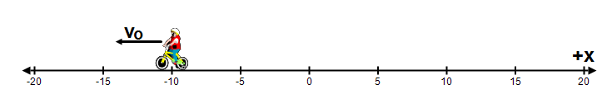

1. A bicyclist moves a long a straight line with an initial velocity v0 and slows down. Which of the following the best describes the signs set for the initial position, initial velocity and the acceleration?

Initial position Initial velocity Acceleration

A. Positive Positive Negative

B. Negative Positive Negative

C. Negative Negative Positive

D. Negative Negative Negative

1. Which of the following is a vector quantity?

A. Traveled distance B. Displacement C. Area D. Mass

1. Which of the following is not a vector quantity?

A. Velocity B. Displacement C. Momentum D. Traveled distance

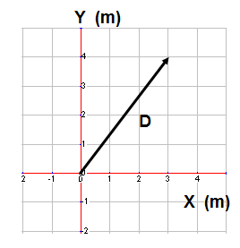

A vector of displacement D is placed in X-Y coordinate system shown in the diagram to the right. Use this diagram to answer questions 28 through 30.

1. What is the x-component of vector D?

A. 2 m B. 3 m C. 4 m D. 5 m

1. What is the y-component of vector D?

A. 2 m B. 3 m C. 4 m D. 5 m

1. What is the magnitude of vector D?

A. 2 m B. 3 m C. 4 m D. 5 m

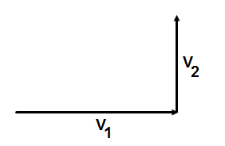

1. An object changes its velocity from V1 to V2 during a time interval Δt. Which of the following is the correct direction for the object’s acceleration?

A. 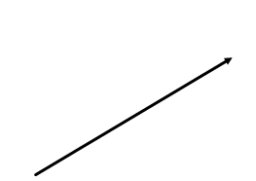 B. 

C.  D.

1. 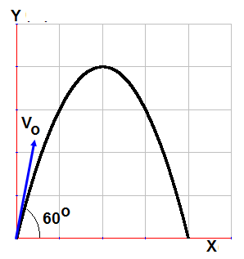A projectile is fired at 60 ̊ above the horizontal line with an initial velocity v0. At which of the following angles the projectile will land at the same distance as it is landed in the first trial?

A. 20 ̊ B. 30 ̊ C. 40 ̊

D. 45 ̊

1. When a projectile reaches the highest point the vertical component of the acceleration is:

A. Greater than g B. Positive g C. Negative g D. Zero

1. When a projectile reaches the highest point the horizontal component of the acceleration is:

A. Less than g B. Positive g C. Negative g D. Zero

1. An object is thrown in horizontal with an initial velocity v0= 5 m/s from the roof of a building 40 m tall. How much later does it hit the ground?

A. 4 s B. $\sqrt{5}$ s C. $\sqrt{8}$ s D. 10 s

1. An object is thrown in horizontal with an initial velocity v0= 10 m/s from the roof of a building 20 m tall. How far from the building does it hit the ground?

A. 5 m B. 10 m C. 15 m D. 20 m

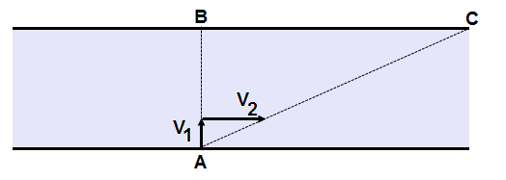

The diagram to the right represents a swimmer. The swimmer is capable to swim in a still water with a velocity V1 = 1 m/s. He aims his body directly across a 100 m wide river whose current has a velocity V2 = 2 m/s. Use this diagram to answer questions 37 through 39.

1. How much time it will take for the swimmer to cross the river?

A. 10 s B. 20 s C. 50 s D. 100 s

1. How far downstream will he land?

A. 100 m B. 200 m C. 150 m D. 180 m

1. What is the velocity of the swimmer relative to the river bank?

A. 1 m/s B. 2 m/s C. $\sqrt{3}$ m/s D. $\sqrt{5}$ m/s



1. The graphs above represent the position, velocity, and acceleration as a function of time for a marble moving in one dimension. Which of the following could describe the motion of the marble?
2. Rolling along the floor and then bouncing off a wall.
3. Rolling down one side of a bowl and then rolling up the other side.
4. Rolling up a ramp and then rolling back down.
5. Falling and then bouncing elastically off a hard floor.

Multi-Correct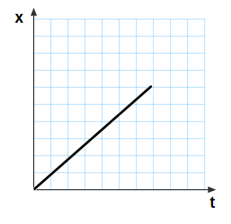 Questions

1. Position as a function of time of a moving object is presented by the graph. Which of the following is true about the type of motion?
2. The object moves with a constant positive acceleration
3. The object moves with a constant positive velocity
4. The slope of this graph is equal to the object’s acceleration
5. The slope of this graph is equal to the object’s velocity

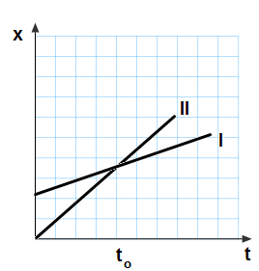

1. Position as a function of time of two moving objects is presented by the graph. Which of the following statements is true?
2. Object I has a greater velocity than object II
3. Object II has a greater velocity that object I
4. At time t0 they have the same velocity
5. At time t0 object II passes by object I

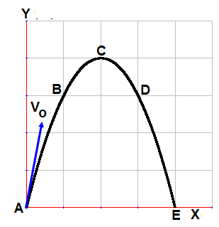

1. A projectile is fired from the ground level with an initial velocity v0. Which of the following statements is true?
2. Vertical component of the velocity at point C is v0 sinθ
3. Horizontal component of the velocity at point C is v0 cosθ
4. The projectile travels with the same speed at point B and D
5. The acceleration at point C is zero

1. An object accelerates from rest at a constant rate. Which of the following graphs could be used to describe the motion of the object?

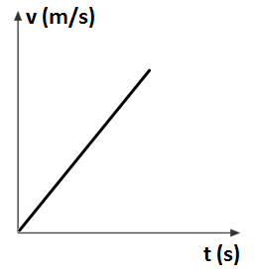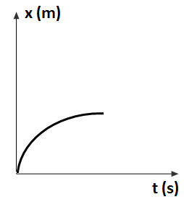

1. 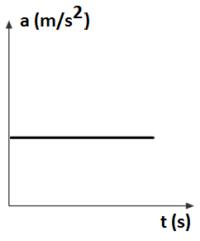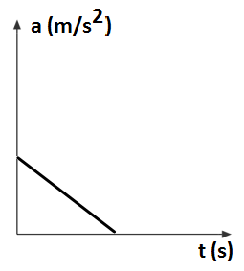 B.

C. D.

1. A tennis ball is thrown straight up and caught at the same height. Which of the following can describe the motion of the ball when it reaches the apex?
2. The velocity of the ball is zero.
3. The acceleration of the ball is zero.
4. The acceleration of the ball is 9.8 m/s2 down
5. The acceleration of the ball is 9.8 m/s2 up.

Free Response Problems

* 1. A car whose speed is 20 m/s passes a stationary motorcycle which immediately gives chase with a constant acceleration of 2.4 m/s2.
     1. How far will the motorcycle travel before catching the car?
     2. How fast will it be going at that time?
     3. How does that compare to the car’s velocity?
     4. Draw the following graphs for the car: x(t), v(t), a(t).
     5. Draw the following graphs for the motorcycle: x(t), v(t), a(t).
     6. Write the equation of motion for the car.
     7. Write the equation of motion for the motorcycle.

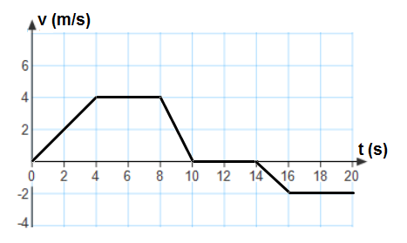

* 1. A lab cart moves a long a straight horizontal track. The graph describes the relationship between the velocity and time of the cart.
     1. Indicate every time interval for which speed (magnitude of the velocity) of the cart is decreasing.
     2. Indicate every time at which the cart is at rest.
     3. Determine the horizontal position x of the cart at t = 4 s if the cart is located at x0 = when t0 = 0.
     4. Determine the traveled distance of the cart over 10 s from the beginning.
     5. Determine the average speed of the cart for this time interval.
     6. Find the acceleration of the cart during time: 0 s -4 s, 4 s – 8 s, 8 s – 10 s, 10 s – 14 s, 14 s – 16 s, 16 s – 20 s.
     7. 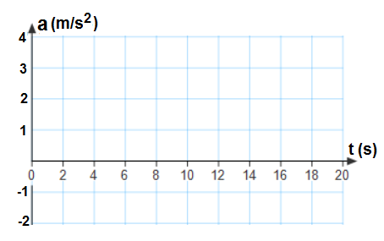 On the axes below, sketch the acceleration graph for the motion of the cart from t = 0 s to t = 20 s.
  2. Find the magnitude and the direction of vector C for the following cases.
     1. A = 10 N at 0 ̊, B = 20 N at 0 ̊, C = A + B
     2. A = 10 N at 0 ̊, B = 20 N at 180 ̊, C = A + B
     3. A = 10 N at 180 ̊, B = 20 N at 180 ̊, C = A + B
     4. A = 10 N at 0 ̊, B = 20 N at 90 ̊, C = A + B
     5. A = 10 N at 90 ̊, B = 20 N at 0 ̊, C = A + B
  3. Find the magnitude and the direction of vector G as a sum of two vectors D and E by going through the following steps.
     1. D = 10 N at 37 ̊. Find Dx and Dy.
     2. E = 20 N at 25 ̊. Find Ex and Ey.
     3. Find Gx = Dx + Ex
     4. Find Gy = Dy + Ey
     5. Find the magnitude of G from its components
     6. Find the direction of G.
  4. Find the magnitude and the direction of vector C for the following cases.
     1. A = 40 N at 0 ̊, B = 10 N at 0 ̊, C = A + B
     2. A = 40 N at 0 ̊, B = 10 N at 180 ̊, C = A + B
     3. A = 40 N at 180 ̊, B = 10 N at 180 ̊, C = A + B
     4. A = 40 N at 0 ̊, B = 10 N at 90 ̊, C = A + B
     5. A = 40 N at 90 ̊, B = 10 N at 0 ̊, C = A + B
  5. Find the magnitude and the direction of vector G as a sum of two vectors D and E by going through the following steps.
     1. D = 30 N at 65 ̊. Find Dx and Dy.
     2. E = 45 N at 15 ̊. Find Ex and Ey.
     3. Find Gx = Dx + Ex
     4. Find Gy = Dy + Ey
     5. Find the magnitude of G from its components
     6. Find the direction of G.
  6. Two forces 300 N at 0 ̊ and 400 N at 90 ̊pull on an object. Answer the following:
     1. Draw a diagram showing the forces acting on the object.
     2. Draw a sketch showing the vector sum of two forces.
     3. Find the magnitude of the resultant force.
     4. Find the direction of the resultant force.
  7. A ship makes three displacements in the following order:
     + 1. 76 mi, 48 ̊ north of east
       2. 50 mi, 56 ̊north of west; and
       3. 47 mi, south
     1. Draw a clear diagram showing all three displacement vectors with respect to horizontal points (north, east, south, and west).
     2. Find the X and Y components of displacement D1.
     3. Find the X and Y components of displacement D2.
     4. Find the X and Y components of displacement D3.
     5. Find the magnitude of the resultant vector.
     6. Find the direction of the resultant vector.
  8. A bus makes three displacements I the following order:
     + 1. 58 mi, 38 ̊ east of north
       2. 69 mi, 46 ̊ west of north; and
       3. 75 mi, south-east
     1. Draw a clear diagram showing all three displacement vectors with respect to horizontal points (north, east, south, and west).
     2. Find the X and Y components of displacement D1.
     3. Find the X and Y components of displacement D2.
     4. Find the X and Y components of displacement D3.
     5. Find the magnitude of the resultant vector.
     6. Find the direction of the resultant vector.
  9. A ball is thrown horizontally from the roof of a building 75 m tall with a speed of 4.6 m/s.
     1. How much later does the ball hit the ground?
     2. How far from the building will it land?
     3. What is the velocity of the ball just before it hits the ground?
  10. A projectile is fired with an initial speed of 150 m/s at an angle of 47 ̊ above the horizontal.
      1. Determine the total time in the air.
      2. Determine the maximum height reached by the projectile.
      3. Determine the maximum horizontal distance covered by the projectile.
      4. Determine the velocity of the projectile 5 s after firing.
  11. A projectile is fired from the edge of a cliff 95 m high with an initial speed of 50 m/s at an angle of 37 ̊ above the horizontal.
      1. Determine the total time in the air.
      2. Determine the maximum height reached by the projectile.
      3. Determine the maximum horizontal distance covered by the projectile.
      4. Determine the velocity of the projectile just before it hits the bottom of the cliff.
  12. A ball is thrown horizontally from the roof of a building 55 m tall with a speed of 3.8 m/s.
      1. How much later does it hit the ground?
      2. How far from the building will it land?
      3. What is the velocity of the ball just before it hits the ground?
  13. A projectile is fired with an initial speed of 110 m/s at an angle of 36 above the horizontal.
      1. Determine the total time in the air.
      2. Determine the maximum height reached by the projectile.
      3. Determine the total horizontal distance covered by the projectile.
      4. Determine the velocity of the projectile 4s after firing.
  14. A ball rolls off a 1.5 m tall horizontal table and lands on the floor .70 m away.
      1. How much time is the ball in the air?
      2. How does that time compare with the time it takes for a dropped ball to fall that same distance.
      3. What is the ball’s velocity while it was on the table top?
      4. What is the horizontal component of its velocity just prior to impact?
      5. What is the vertical component of its velocity just prior to impact?
      6. What is the magnitude of its velocity just prior to impact?
      7. What is the direction of its velocity just prior to impact?
  15. An archer fires an arrow with a velocity of 42 m/s at an angle of 35 degrees above horizontal?
      1. What is the horizontal component of its initial velocity?
      2. What is the vertical component of its initial velocity?
      3. What is the maximum height attained by the arrow?
      4. How long does it take the arrow to reach that height?
      5. What is the total amount of time that it’s in the air?
      6. How far away does it strike the ground?
      7. What is the horizontal component of its velocity just prior to impact?
      8. What is the vertical component of its velocity just prior to impact?
      9. What is the magnitude of its velocity just prior to impact?
      10. What is the direction of its velocity just prior to impact?
  16. A cannon is fired horizontally from a cliff 112m high with a speed of 25 m/s.
      1. How much later does the cannon ball hit the ground?
      2. How far from the cliff will it land?
      3. What is the velocity of the cannon ball just before it hits the ground?
  17. A ball is thrown horizontally from the roof of a building 12 m tall with a speed of 3.1 m/s.
      1. How much later does the ball hit the ground?
      2. How far from the building will it land?
      3. What is the velocity of the ball just before it hits the ground?
  18. A gazelle leaps from a cliff 2.5 m high with a speed of 5.6 m/s.
      1. How much later does the gazelle hit the ground?
      2. How far from the cliff will it land?
      3. What is the velocity of the gazelle just before it hits the ground?
  19. A projectile is fired with an initial speed of 40 m/s at an angle of 23 degrees above the horizontal.
      1. Determine the total time in the air.
      2. Determine the maximum height reached by the projectile.
      3. Determine the maximum horizontal distance covered by the projectile.
      4. Determine the velocity of the projectile 2s after firing.
  20. A hose held near the ground shoots water at a speed of 3.5 m/s at an angle of 72 degrees above the horizontal.
      1. Determine the total time of the water in the air.
      2. Determine the maximum height reached by the water.
      3. Determine the maximum horizontal distance covered by the water.
  21. You are riding your bike at 10 m/s when you see your friend 20 m in front of you. You apply the brakes and slow down with a rate of 2.5 m/s2.
      1. Write and equation that can describe your position at a function of time.
      2. Write and equation that can describe your velocity as a function of time.
      3. On the graphs below sketch the velocity vs. time and position vs. time graphs.

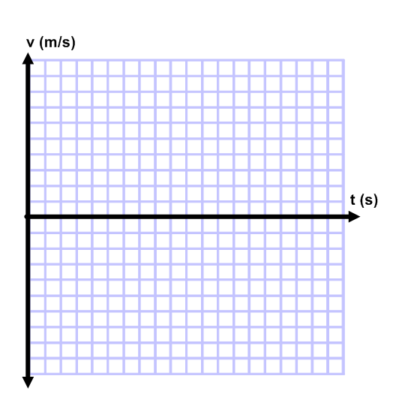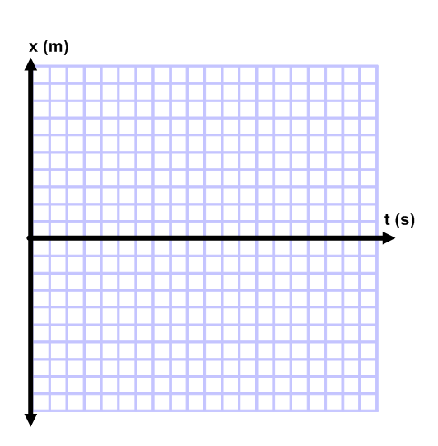

* + 1. How long will it take you to come to a complete stop? Justify your answer.
    2. Will you come to a stop before you get to your friend, exactly where your friend is standing, or after you pass your friend? Justify your answer.

Answers

Multiple Choice

* 1. B
  2. D
  3. B
  4. B
  5. C
  6. D
  7. B
  8. B
  9. C
  10. B
  11. B
  12. D
  13. B
  14. D
  15. C
  16. C
  17. D
  18. C
  19. B
  20. B
  21. D
  22. D
  23. B
  24. D
  25. C
  26. B
  27. D
  28. B
  29. C
  30. D
  31. B
  32. B
  33. C
  34. D
  35. C
  36. D
  37. D
  38. B
  39. D
  40. B
  41. B & D
  42. B & D
  43. B & C
  44. B & D
  45. A & C

Free Response

1. a. 333 m

b. 40 m/s

c. twice the speed

d. 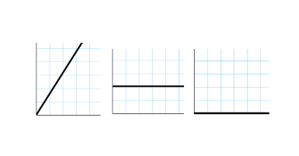

e.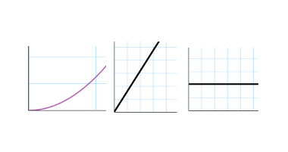

f. $x=\left(20\frac{m}{s}\right)t$

g. $x=\frac{1}{2}\left(2.4\frac{m}{s^{2}}\right)t$

1. a. 8 to 10 s

b. 10 to 14 s

c. 8 m

d. 28 m

e. 2.8 m/s

f. 1 m/s2, 0, -2 m/s2, 0, -1 m/s2, 0

g. 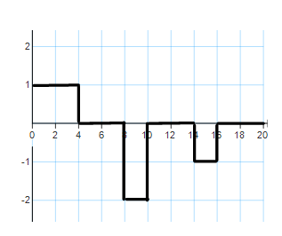

1. a. 30N at 0o

b. 10N at 180o

c. 30N at 180o

d. 22.4N at 63o

e. 22.4 at 26.6o

1. a. 8.0 N and 6.0 N

b. 18.1 N and 8.5 N

c. 26.1 N

d. 12.7 N

e. 29 N

f. 25.9 o

1. a. 50 N at 0o

b. 30 N at 0o

c. 50 N at 180o

d. 41.2 N at 14o

e. 41.2 N at 76o

1. a. 12.7 N and 27.2 N

b. 43.5 N and 11.6 N

c. 56.2 N

d. 38.8 N

e. 68.3 N

f. 34.6o

1. a. 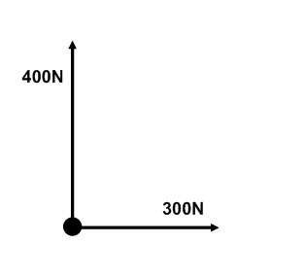

b. 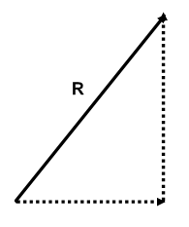

c. 500 N

d. 53.1o

1. a. 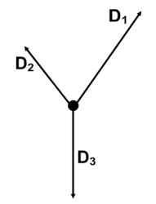

b. 50.9 mi and 56.5 mi

c. -27.9 mi and 41.5 mi

d. 0 mi and -47 mi

e. 55.9 mi

f. 65.7o North of East

1. a. 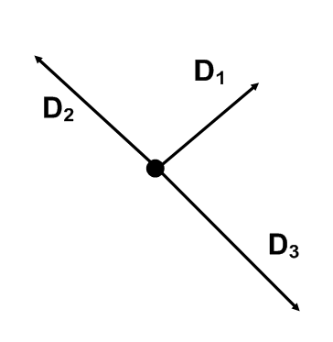

b. 35.7 mi and 45.7 mi

c. -49.6 mi and 47.9 mi

d. 53.0 mi and -53.0 mi

e. 56.4 mi

f. 46.1o

1. a. 3.9 s

b. 18 m

c. 39.3 m/s at 305 o

1. a. 22 s

b. 614 m

c. 2244 m

d. 119 m/s, 30.7°

1. a. 8.4 s

b. 140 m

c. 335.2 m/s

d. 65.7 m/s at 54 o

1. a. 3.4 s

b. 12.7 m

c. 33 m/s

1. a. 13.3 s

b. 215.6 m

c. 1184 m

d. 92.4 m/s 15° above horizontal

1. a. 0.55 s

b. The time is the same.

c. 1.27 m/s

d. 1.27 m/s

e. -5.39 m/s

f. 5.54 m/s

g. 76.7° below horizontal

1. a. 34 m/s

b. 24 m/s

c. 29.4 m

d. 2.4 s

e. 4.8 s

f. 169 m

g. 34 m/s

h. -24 m/s

i. 42 m/s

j. 35° below horizontal

1. a. 4.8 s

b. 119.5 m

c. 53 m/s 61° below horizontal

1. a. 1.56 s

b. 4.85 m

c. 15.6 m/s 79° below horizontal

1. a. 0.7 s

b. 4 m

c. 8.9 m/s 50° below horizontal

1. a. 3.2 s

b. 11.5 m

c. 118 m

d. 37.2 m/s 6° below horizontal

1. a. 3.3 m/s

b. 0.68 s

c. 0.56 m

1. a. $x=\left(-20m\right)+\left(10m/s\right)t+\frac{1}{2}\left(-2.5m/s^{2}\right)t^{2}$

b. $v=\left(10m/s\right)+\left(-2.5m/s^{2}\right)$ t

c.

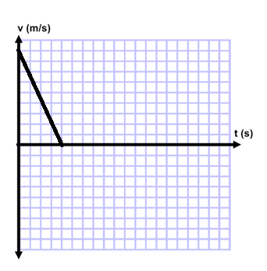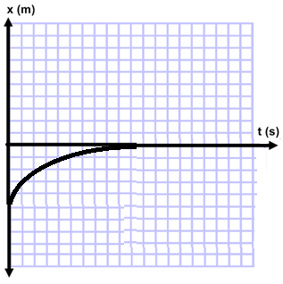

d. 4s

e. Exactly where your friend is standing.

$x=\left(-20m\right)+\left(10\frac{m}{s}\right)\left(4s\right)+\frac{1}{2}\left(-2.5\frac{m}{s^{2}}\right){\left(4s\right)}^{2}=0$