***Electric Potential Practice Problems***

*PSI Physics* Name____________________________________

Multiple Choice

1. A negative charge is placed on a conducting sphere. Which statement is true about the charge distribution

(A) Concentrated at the center of the sphere

(B) Charge density increases from the center to the surface

(C) Uniformly distributed on the sphere's outer surface.

(D) Uniformly distributed inside the sphere

(E) More information is required

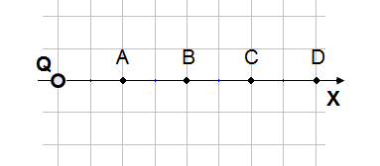

1. An electric charge Q is placed at the origin. What is the ratio between the absolute potential at point A and point B?

(A) 4/1 (B) 2/1 (C) 1 (D) 1/2 (E) ¼

1. Which of the following statements about conductors under electrostatic conditions is true?

(A) Positive work is required to move a positive charge over the surface of a conductor.

(B) Charge that is placed on the surface of a conductor always spreads evenly over the surface.

(C) The electric potential inside a conductor is always zero.

(D) The electric field at the surface of a conductor is tangent to the surface.

(E) The surface of a conductor is always an equipo­tential surface.

1. Which of the following represents the magnitude, of the potential V as function of r, the distance from the center of a conducting sphere charged with a positive charge Q, when r > R?

(A) 0

(B) kQ/R

(C) kQ/r

(D) kQ/R2

(E) kQ/r2

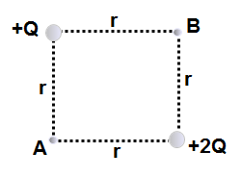

1. Points A and B are each the same distance r from two unequal charges, +Q and +2Q. The work required to move a charge q from point A to point B is:

(A) dependent on the path taken from A to B

(B) directly proportional to the distance between A and B

(C) positive (D) zero (E) negative

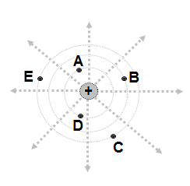

1. An electric field is created by a positive charge. The distribution of the electric field lines and equipotential lines is presented on the diagram. Which statement about electric potential is true?
2. VA > VB > VC > VD > VE
3. VA < VB < VC < VD < VE
4. VA = VD > VB > VC = VE
5. VA > VB = VC > VD = VE
6. VA > VB > VC = VD = VE



1. An electric field is created by a positive charge. The distribution of the electric field lines and equipotential lines is presented on the diagram. A test charge +q is moved from point to point in the electric field. Which statement about work done by the electric field on charge +q is true?
2. WA→B>WA→C (B) WA→D>WA→E

(C) WD→C<WA→E (D) WA→D=WC→E =0

(E) WA→B=WA→E 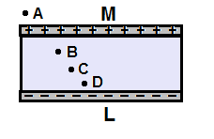

1. Two parallel conducting plates are charged with an equal and opposite charges. Which statement is true about the magnitude of the electric potential?
   * 1. Greater at point A (B) Greater at point B (C) Greater at point C

(D) Greater at point D (E) The same at points B, C, D and zero at point A

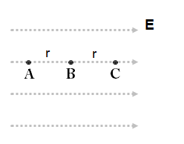

1. A point charge q is released from rest at point A and accelerates in a uniform electric field E. What is the ratio between the work done by the field on the charge: WA→B/WB→C?
2. 1/2 (B) 1/4 (C) 1 (D) 2/1 (E) 4/1



1. A point charge q is released from rest at point A and accelerates in a uniform electric field E. What is the ratio between velocities of the charge VB/VC?
   * 1. (B) (C) 1 (D) (E)

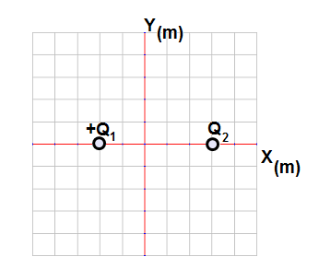

1. A point charge Q1 = +4.0 µC is placed at point -2 m. A second charge Q2 is placed at point +3 m. The net electric potential at the origin is zero. What is charge Q2?

Magnitude Sign

1. 9.0 µC Positive
2. 6.0 µC Positive
3. 3.0 µC Positive
4. 6.0 µC Negative
5. 9.0 µC Negative

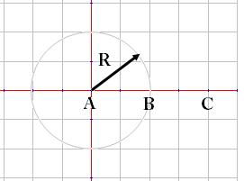

1. A conducting sphere is charged with a positive charge +Q. Which of the following is correct relationship for the electric potential at the points A, B, and C?
2. VA < VB < VC
3. VA > VB < VC
4. VA < VB > VC
5. VA = VB < VC
6. VA = VB > VC

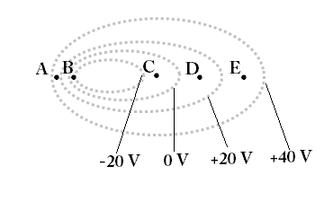

1. An electric field is presented by a series of equipotential lines. At which location is the electric field strength the greatest?
2. A (B) B (C) C (D) D (E) C

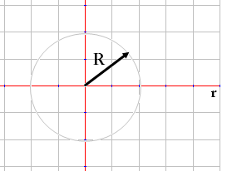

1. A uniform conducting sphere of radius R is charged with a positive charge +Q. Which of the following is correct relationship between the potential and distance from the center of the sphere?
2. 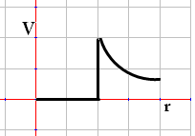 (B)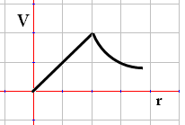

(C)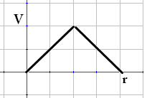 (D)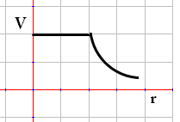

(E)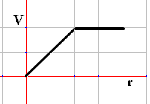



1. A uniform conducting sphere of radius R is charged with a positive charge +Q. Which of the following is correct relationship between the electric field and distance from the center of the sphere?
2. 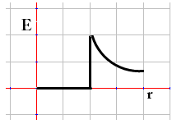(B)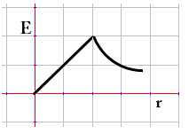

(C)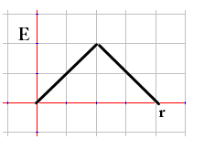 (D)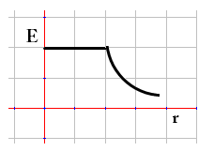

(E)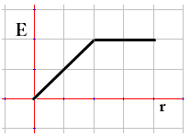

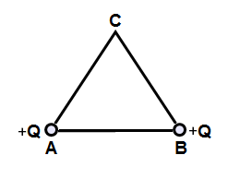

1. Two positive charges A and B are placed at the corners of equilateral triangle with a side r. What is the net electric potential at point C?

(A) $\frac{\sqrt{2}kQ}{r}$ (B) $\frac{\sqrt{3}kQ}{r}$ (C) $\frac{kQ}{r}$ (D) $\frac{\sqrt{5}kQ}{r}$ (E) $\frac{2kQ}{r}$

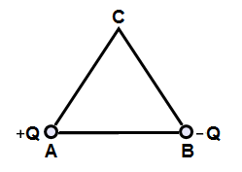

1. Two charges +Q and –Q are placed at the corners of equilateral triangle with a side r. What is the net electric potential at point C?
2. 0 (B) $\frac{\sqrt{3}kQ}{r}$ (C) $\frac{kQ}{r}$ (D) $\frac{\sqrt{5}kQ}{r}$ (E) $\frac{2kQ}{r}$

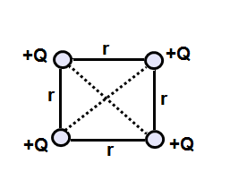

1. Four positive Q charges are arranged in the corner of a square as shown on the diagram. What is the net electric potential at the center of the square?
2. 0 (B) $\frac{8kQ}{\sqrt{2}r}$ (C) $\frac{4kQ}{\sqrt{2}r}$ (D) $\frac{16kQ}{\sqrt{2}r}$ (E) $\frac{2kQ}{\sqrt{2}r}$

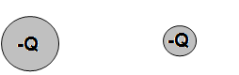

1. Two conducting spheres of different radii are charged with the same charge -Q. What will happen to the charge if the spheres are connected with a conducting wire?
2. Negative charge flows from the large sphere to the smaller sphere until the electric field at the surface of each sphere is the same
3. Negative charge flows from the smaller sphere to the larger sphere until the electric field at the surface of each sphere is the same
4. Negative charge flows from the large sphere to the smaller sphere until the electric potential at the surface of each sphere is the same
5. Negative charge flows from the smaller sphere to the larger sphere the electric potential at the surface of each sphere is the same
6. There is no charge flow between the spheres
7. A charged particle is projected with its initial velocity perpendicular to a uniform electric field. The resulting path of the particle is:

(A) spiral (B) parabolic arc (C) circular arc

(D) straight line parallel to the field

(E) straight line perpendicular to the field

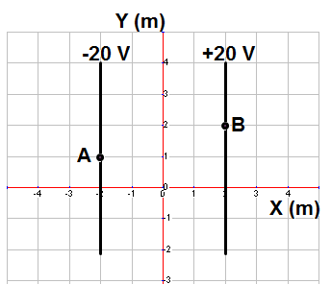

1. A positive charge of +3 µC is moved from point A to point B in a uniform electric field. How much work is done by the electric field on the charge?
2. 100 µJ (B) 120 µJ (C) 140 µJ (D) 160 µJ (E) 180 µJ

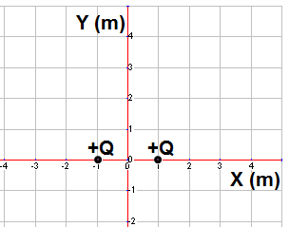

1. Two positive charges with a magnitude of Q are located at points (+1,0) and (-1,0). At which of the following points is the electric potential the greatest in magnitude?
2. (+2,0) (B) (0,-1) (C) (0,0) (D) (+3,0) (E) (0,+1)

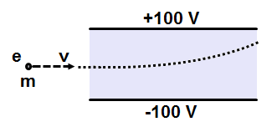

1. An electron with energy of 200 eV enters a uniform electric field parallel to the plates. The electron is deflected by the electric field. What is the kinetic energy of the electron just before it strikes the upper plate?
2. 50 eV (B) 100 eV (C) 200 eV (D) 300 eV (E) 400 eV
3. A parallel-plate capacitor has a capacitance C0. What is the capacitance of the capacitor if the area is doubled and separation between the plates is doubled?

(A) 4 C0 (B) 2 C0 (C) C0 (D) 1/2 C0 (E) 1/4 C0

1. A parallel-plate capacitor is charged by a battery and then disconnected. What will happen to the charge on the capacitor and voltage across it if the separation between the plates is decreased and the area is increased?
2. Both increase (B) Both decrease (C) Both remain the same

(D) The charge remains the same and voltage increases

(E) The charge remains the same and voltage decreases

1. A parallel-plate capacitor is charged by connection to a battery and remains connected. What will happen to the charge on the capacitor and voltage across it if the separation between the plates is decreased and the area is increased?
2. Both increase (B) Both decrease (C) Both remain the same

(D) The voltage remains the same and charge increases

(E) The voltage remains the same and charge decreases

1. A parallel-plate capacitor is connected to a battery with a constant voltage. What happens to capacitance, charge, and voltage if a dielectric material is placed between the plates?

Capacitance Charge Voltage

1. Increases Increases Decreases
2. Decreases Increases Remains the same
3. Remains the same Decreases Increases
4. Increases Increases Remains the same
5. Decreases Remains the same Increases
6. A parallel-plate capacitor is connected to a battery and becomes fully charged. The capacitor is then disconnected, and the separation between the plates is increased in such a way that no charge leaks off. What happens to the energy stored in the capacitor?
7. Remains the same (B) Increased (C) Decreased

(D) Zero (E) More information is required

1. A parallel-plate capacitor is connected to a battery with a constant voltage. The capacitor becomes fully charged and stays connected. What happens to the energy stored in the capacitor if the separation is decreased?
2. Remains the same (B) Increased (C) Decreased

(D) Zero (E) More information is required

1. A parallel-plate capacitor is connected to a battery. The capacitor is fully charged before the battery is disconnected. A uniform dielectric with a constant K is inserted between the plates. What is the ratio between the energy stored in the capacitor with the inserted dielectric Uk to the energy without dielectric U0?
2. 1/K (B) 1/K2 (C) K/1 (D) K2/1 (E) 1
3. Two parallel conducting plates are connected to a battery with a constant voltage. The magnitude of the elec­tric field between the plates is 1200 N/C. If the voltage is halved and the distance between the plates is tripled from the original distance. The magnitude of the new electric field is:

(A) 800 N/C (B) 600 N/C (C) 400 N/C (D) 500 N/C

(E) 200 N/C

Multi-correct Multiple Choice

1. Which of the following statements is true about the charged conducting sphere?
   * 1. The electric field is maximum at the center of the sphere
     2. The electric potential is minimum at the center of the sphere
     3. The electric field is zero inside the sphere
     4. The electric potential everywhere inside the sphere and at the surface is the same
2. Which of the following is true about the electro-static filed?
   * 1. The electric file lines are parallel to the equipotential lines
     2. The electric file lines are perpendicular to the equipotential lines
     3. The electric field lines point in the direction where potential is less
     4. The electric field lines point in the direction where potential is greater
3. A parallel plate capacitor is fully charged and disconnected form a battery. When the space between the plates is filled with a dielectric the charge, voltage and energy stored in the capacitor are:
   * 1. Charge stays the same and energy increases
     2. Charge stays the same and energy decreases
     3. Charge stays the same and voltage increases
     4. Charge stays the same and voltage decreases
4. A parallel plate capacitor is fully charged and stays connected to a battery. When the space between the plates is filled with a dielectric the charge, voltage and energy stored in the capacitor are:
   * 1. Voltage stays the same and energy increases
     2. Voltage stays the same and energy decreases
     3. Voltage stays the same and charge increases
     4. Voltage stays the same and charge decreases

Chapter Problems

## **Electric Potential Energy**

## **Classwork**

1. What is the potential energy of an electron and a proton in a hydrogen atom if the distance between them is 5.3 x 10-11 m?
2. What is the potential energy of two charges of +4.2 μC and +6.1 μC which are separated by a distance of 50.0 cm?
3. What is the potential energy of two charges of -3.6 μC and +5.2 μC which are separated by a distance of 75.0 cm?
4. There are three charges, 4.0 µC, 3.5 µC and -6.4 µC, each at the vertex of an equilateral triangle of side length 0.020m. What is the potential energy of the system?

**Homework**

1. What is the potential energy of two charges of -5.2 μC and -8.2 μC which are separated by a distance of 50 cm?
2. What is the potential energy of two charges of 4.2 μC and -6.1 μC which are separated by a distance of 75.0 cm?
3. What is the potential energy of two electrons that are separated by a distance of 3.5 x 10-11 m?
4. What is the potential energy of three charges of 2.0 µC, -4.5 µC and -3.4 µC that are in a straight line, with the -4.5 µC charge in the middle, and each charge is 5.0 cm away from its adjacent charge?

## **Electric Potential (Voltage)**

## **Classwork**

1. Draw Equipotential lines due to a positive point charge.
2. What is the electric potential 50.0 cm from a –7.4 μC point charge?
3. What is the electric potential 25 cm from a +5.0 μC point charge?
4. Two point charges of +3.5 μC and +8.3 μC are separated by a distance of 4.0 m. What is the electric potential midway between the charges?
5. A proton passes through a potential difference of 350 V. Find its kinetic energy and velocity (e = 1.60 x 10-19 C, mp = 1.67 x 10-27 kg).
6. How much work is done in moving a +2.6 µC charged particle from a point wth a potential of 100.0 V to a point with a potential of 20.0 V?
7. An Electric Field does 40.0 mJ of work to move a +6.8 μC charge from one point to another. What is the potential difference between these two points?

**Homework**

1. Draw Equipotential lines due to a negative point charge.
2. What is the electric potential 65.0 cm from a –8.2 μC point charge?
3. What is the electric potential 30.0 cm from a +6.8 μC point charge?
4. Two point charges of +2.5 μC and -6.8 μC are separated by a distance of 4.0 m. What is the electric potential midway between the charges?
5. An electron falls through a potential difference of 200.0 V. Find its kinetic energy and velocity (e = 1.60 x 10-19 C, me = 9.11 x 10-31 kg).
6. An Electric Field does 25 mJ of work to move a +7.4 μC charge from one point to another. What is the potential difference between these two points?
7. How much work is required by an Electric Field to move a -4.3 μC from a point with a potential 50.0 V to a point with a potential –30.0 V?
8. An Electric Field does 150 μJ of work to move a –8.4 μC charge from one point to another? What is the potential difference between these two points?

## **Uniform Electric Field**

## **Classwork**

1. Draw Equipotential lines in a uniform Electric Field, with the positive line of charge on the top, and the negative line of charge on the bottom.
2. An Electric Field of 440 N/C is desired between two plates which are 4.6 mm apart; what voltage should be applied?
3. What is the magnitude of the electric force on an electron in a uniform Electric Field of 2,500 N/C?
4. A 240 V power supply creates an Electric Field of 4.5 x 106 N/C between two parallel plates. What is the separation between the plates?
5. A proton is accelerated by a uniform 360 N/C Electric Field. Find the kinetic energy and the velocity of the proton after it has traveled 50.0 cm.
6. A uniform 450 N/C Electric Field moves a +3.4 μC charge 10.0 cm; how much work is done by the Electric Field?
7. How much work is done by a uniform 760 N/C Electric Field on a proton in accelerating it through a distance of 60.0 cm?
8. What is the magnitude and direction of the electric force on an electron in a uniform Electric Field of 4200 N/C that points due west? What is the acceleration of the electron?

**Homework**

1. Draw Equipotential lines in a uniform Electric Field, with the negative line of charge on the top, and the positive line of charge on the bottom.
2. How strong is the Electric Field between two metal plates 5.0 mm apart if the potential difference between them is 240 V?
3. How much voltage should be applied to two parallel plates, which are 12 mm apart, in order to produce a 1500 N/C Electric Field between them?
4. Two plates are connected to a 120 V battery which have a small air gap. How small can the gap be if the Electric Field cannot exceed the air’s breakdown value of 5.0 x 106 N/C, causing a spark?
5. An electron is released from rest in a uniform Electric Field and accelerates to the west at a rate of 2.4 x 108 m/s2. What is the magnitude and direction of the Electric Field?
6. An electron falls a distance of 25 cm in a uniform 500.0 N/C Electric Field; how much work is done on the electron?
7. A potential difference of 120 V is applied between two parallel plates. What is the Electric Field strength between the plates if they are 2.5 mm apart?
8. An initially stationary electron is accelerated by a uniform 640 N/C Electric Field. Find the kinetic energy and velocity of the electron after it has traveled 15 cm.

Free-Response problems

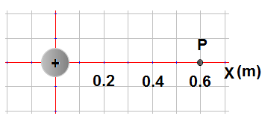

1. A charged sphere A has a charge of +9 µC and is placed at the origin.
   1. What is the electric potential at point P located 0.6 m from the origin?

A point charge with a charge of+3 µC and mass of 5 g is brought from infinity to point P.

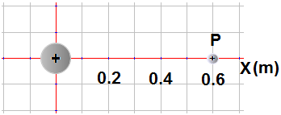

* 1. How much work is done to bring the point charge from infinity to point P?
  2. What is the electric force between two charges?
  3. What is the net electric field at point 0.3 m from the origin?

The sphere stays fixed and point charge is released from rest.

* 1. What is the speed of the point charge when it is far away from the origin?

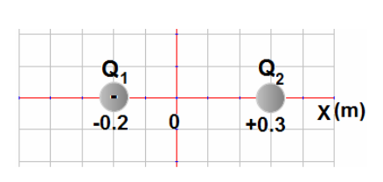

1. Two charges are separated by a distance of 0.5 m. Charge Q1 = -9 µC. The electric field at the origin is zero.
2. What is the magnitude and sign of charge Q2?
3. What is the magnitude and direction of the electric force between the charges?
4. What is the electric energy of the system of two charges?
5. What is the net electric potential at the origin?
6. How much work is required to bring a negative charge of -1 nc from infinity to the origin?

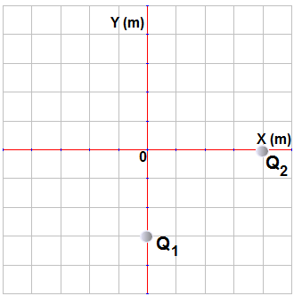

1. A charge Q1 = +9 µC is placed on the y-axis at -3 m, and charge Q2 = -16 µC is placed at the x-axis at +4 m.
2. What is the magnitude of the electric force between the charges?
3. On the diagram below show the direction of the net electric field at the origin.

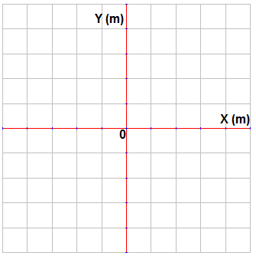

1. What is the magnitude of the net electric field at the origin?
2. What is the electric energy of the system of two charges?
3. What is the net potential at the origin?
4. How much work is required to bring a small charge +1 nC from infinity to the origin?

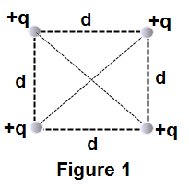

1. Four equal and positive charges +q are arranged as shown on figure 1.
2. Calculate the net electric field at the center of square?
3. Calculate the net electric potential at the center of square?
4. How much work is required to bring a charge q0 from infinity to the center of square?

Two positive charges are replaced with equal negative charges, figure 2.

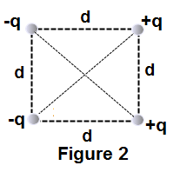

1. Calculate the net electric field at the center of square.
2. Calculate the net electric potential at the center of square.
3. How much work is required to bring a charge q0 from infinity to the center of square?

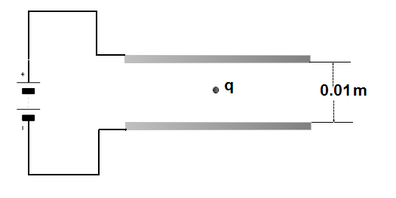

1. In an oil-drop experiment, two parallel conducting plates are connected to a power supply with a constant voltage of 100 V. The separation between the plates is 0.01 m. A 4.8x10-16 kg oil drop is suspended in the region between the plates. Use g = 10 m/s2.
   * 1. What is the direction of the electric field between the plates?
     2. What is the magnitude of the electric field between the plates?
     3. What is the sign and magnitude of the electric charge on the oil drop when it stays stationary?

The mass of the drop is reduced to 3.2*10-16 kg because of vaporization.

* + 1. What is the acceleration of the drop?

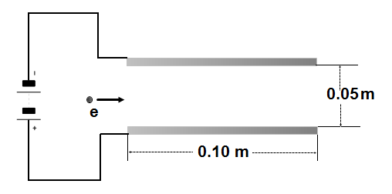

1. A parallel-plate capacitor is connected to a battery with a constant voltage of 120 V. Each plate has a length of 0.1 m and they are separated by a distance of 0.05 m. An electron with an initial velocity of 2.9*107 m/s is moving horizontally and enters the space between the plates. Ignore gravitation.
2. What is the direction of the electric field between the plates?
3. Calculate the magnitude of the electric field between the plates.
4. Describe the electron’s path when it moves between the plates.
5. What is the direction and magnitude of its acceleration?
6. Will the electron leave the space between the plates?

Answers to Multiple Choice:

1. C
2. B
3. E
4. C
5. D
6. C
7. D
8. B
9. C
10. A
11. D
12. E
13. B
14. D
15. A
16. E
17. A
18. B
19. D
20. B
21. B
22. C
23. D
24. C
25. E
26. D
27. D
28. B
29. B
30. A
31. E
32. C,D
33. B,C
34. B,D
35. A,C

Chapter Problems

1. -4.4 x 10-18 J
2. 4.6 x 10-1 J
3. -2.2 x 10-1 J
4. -1.5 x 101 J
5. 7.7 x 10-1 J
6. -3.1 x 10-1 J
7. 6.6 x 10-18 J
8. 5.2 x 10-1 J

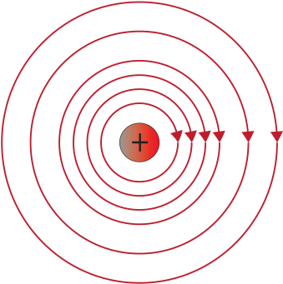

1. -1.3 x 105 V
2. 1.8 x 105 V
3. 5.3 x 104 V
4. KE = 5.6 x 10-17 J; v = 2.6 x 105 m/s
5. -2.1 x 10-4 J
6. 5.9 x 103 V
7. 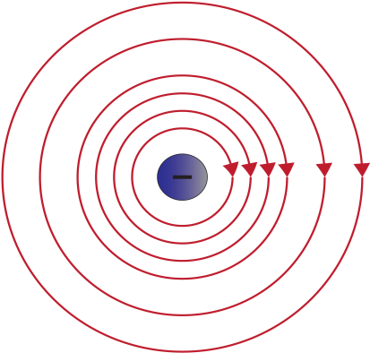
8. -1.1 x 105 V
9. 2.0 x 105 V
10. -1.9 x 104 V
11. KE = 3.2 x 10-17 J; v = 8.4 x 106 m/s
12. 3.4 x 103 V
13. -3.4 x 10-4 J
14. 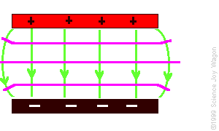18 V

The horizontal lines

are the Equipotentials.

1. 2.0 V
2. 4 x 10-16 N
3. 5.3 x 10-5 m
4. KE = 2.9 x 10-17 J; v = 1.9 x 105 m/s
5. 1.5 x 10-4 J
6. 7.3 x 10-17 J
7. FE = 6.7 x 10-16  N to East; a = 7.4 x 1014 m/s2
8. 

The horizontal lines are the equipotentials.

1. 4.8 x 104 V/m
2. 18 V
3. 2.4 x 10-5 V
4. 1.4 x 10-3 N/C towards the East
5. -2.0 x 10-17 J
6. 4.8 x 104 V/m
7. KE = 1.5 x 10-17 J; v = 5.8 x 106 m/s

General Problems

1. a. 1.35 x 105 V  
   b. 0.4 J  
   c. 0.675 N  
   d. 6 X 10 6 V/m  
   e. 12.6 m/s
2. a. -2 x 10-5 C  
   b. 6.48 N; Away  
   c. 3.24 J  
   d. -10.1 x 105 V  
   e. 1 x 10-3 J
3. 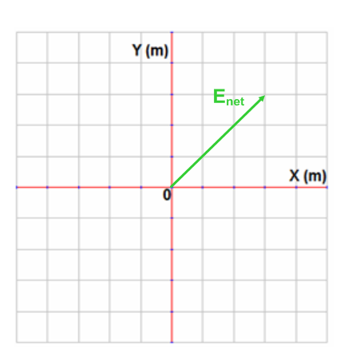a. 0.052 N  
   b.

c. 13,000 N/C  
d. -0.26 J  
e. -9,000 V  
f. -9 x 10-6 J

1. a. 0  
   b. 4(2) kq/d  
   c. 4(2) kqqO/d  
   d. (2) 4kq/d2  
   e. 0  
   f. 0
2. a. Down  
   b. 10,000 V/m  
   c. 4.8 x 10-19‑ C; must be negative  
   d. 5 m/s2
3. a. Up  
   b. 2,400 V/m  
   c. Parabolic, Downward  
   d. 4.2 x 1014 m/s2   
   e. It will leave the plates