**PSI AP Physics I**

**Dynamics Chapter Questions**

1. What is Newton’s First Law?
2. Can an object with zero net force acting on it be moving? Explain.
3. Discuss how an object’s acceleration relates to the direction of its movement.
4. A box is placed on a table. Describe the action-reaction forces between the box and the table, the box and the earth’s gravitational field, and the table and the earth’s gravitational field.
5. You are on a train. A baseball that is initially at rest in the aisle suddenly starts moving backwards without an applied force. Apply the definition of an inertial reference frame to explain what is happening.
6. Compare/contrast the physically measured quantities of mass and weight.
7. What is the normal force?
8. Explain the differences between kinetic and static friction without using equations.
9. What is a free body diagram and how is it used to solve for the motion of an object?
10. When there is friction between a moving object and the surface it rests on in the x axis, why is it necessary to first apply Newton’s Second Law to the free body diagram in the y direction?
11. What assumption is made about moving objects on a surface oriented in the x axis that results in FN = mg?
12. You are pulling a wagon with a handle that is at an angle θ with respect to the horizontal x axis with a force F.
    1. Explain how you would find how much of F results in acceleration of the wagon in the x axis.
    2. Assume there is friction between the wagon and the ground. How do you determine the value of the frictional force, using the y component of the applied force F?
    3. Instead of pulling the wagon, you push it with the handle oriented at the same angle with respect to the horizontal. Compare the frictional force to when the wagon was being pulled.
13. An object is moving with constant velocity downwards on a frictionless inclined plane that makes an angle of θ with the horizontal.
    1. Which direction does the force of gravity act on the object?
    2. Which direction does the normal force act on the object?
    3. Which force is responsible for the object moving down the incline?
14. Give two reasons why the x-y coordinate axes are rotated to align with the inclined plane.
15. For an object to remain at rest, it is necessary for it to be in translational equilibrium. What can you say about the net force on the object for this to be true?
16. A box of mass m is suspended by two ropes from a ceiling.
    1. If the ropes make the same angle with the vertical, what is the tension in each rope?
    2. The ropes make different angles with the vertical, one being more vertical than the other. Which rope has the greatest tension?
    3. Why can the ropes that support the box never be perfectly horizontal?

**Chapter Problems**

1. **Review of One Dimensional Dynamics**

**Classwork**

1. A net force F acts on a mass m and produces an acceleration a. What acceleration results if a net force 4F acts on a mass 6m?
2. A net force F acts on a mass m and produces an acceleration a. What acceleration results if a net force 3F acts on a mass 5m?
3. A net force F acts on a mass m and produces an acceleration a. What force is required to produce an acceleration of 3a if the mass is increased to 6m?
4. A net force F acts on a mass m and produces an acceleration a. What mass would accelerate at a rate 8a if the force is decreased to F/2?
5. A box is sitting on a desk. The box has a mass of 52 kg. What is the magnitude of the normal force acting on the box by the desk? What is the weight of the box?
6. A car bumps into a tree with a force of 3200N. What force does the tree exert on the car?
7. A rope is tied to a ceiling and a light fixture of mass 12 kg is supported by it. What is the tension force in the rope?
8. What is the kinetic friction force on an object of mass 37 kg as it moves over a surface where μk = 0.22?
9. Does a couch of mass 150 kg move on a carpeted floor with μs = 0.33 and μk = 0.22, if it is pushed with a force of 400N?
10. A force of 525 N is applied to a stationary couch of mass 150 kg, where μs = 0.33 and μk = 0.22. What is the acceleration of the couch?

**Homework**

1. A net force F acts on a mass m and produces an acceleration a. What acceleration results if a net force 3F acts on a mass 8m?
2. A net force F acts on a mass m and produces an acceleration a. What acceleration results if a net force 7F acts on a mass 2m?
3. A net force F acts on a mass m and produces an acceleration a. What force is required to produce an acceleration of 9a if the mass is increased to 2m?
4. A net force F acts on a mass m and produces an acceleration a. What mass would accelerate at a rate 9a if the force is decreased to F/3?
5. A box is sitting on a desk. The box has a mass of 45 kg. What is the magnitude of the normal force acting on the box by the desk? What is the weight of the box?
6. A car bumps into a tree with a force of 4500 N. What force does the tree exert on the car?
7. A rope is tied to a ceiling and a light fixture of mass 16 kg is supported by it. What is the tension force in the rope?
8. What is the kinetic friction force on an object of mass 45 kg as it moves over a surface where μk = 0.11?
9. Does a couch of mass 125 kg move on a carpeted floor with μs = 0.48 and μk = 0.37, if it is pushed with a force of 500 N? Why?
10. A force of 625 N is applied to a stationary couch of mass 125 kg, where μs = 0.48 and μk = 0.37. What is the acceleration of the couch?
11. **Resolving Forces into Two Dimensions**

**Classwork**

1. What are the x and y components of the force vectors shown below?
   1. b) c) d)
2. What are the x and y components of the force vectors shown below?
   1. b) c) d)

**Homework**

1. What are the x and y components of the force vectors shown below?
   1. b) c) d)
2. What are the x and y components of the force vectors shown below?
   1. b) c) d)
3. **Two Dimensional Forces**

**Classwork**

1. A box of mass 24 kg is being pulled horizontally on a rough surface by an applied force of 585 N. The coefficient of kinetic friction is 0.23 between the box and the surface.
   1. Draw the free body diagram.
   2. Find the Normal force on the box.
   3. Find the acceleration of the box.
2. A couch of mass 210 kg is being pushed across the floor with an applied force of 4100 N. The coefficient of kinetic friction between the couch and the floor is 0.38.
   1. Draw the free body diagram.
   2. Find the Normal force on the couch.
   3. Find the acceleration of the couch.
3. A 45 kg wagon is being pulled with a rope that makes an angle of 380 with the horizontal. The applied force is 410 N and the coefficient of kinetic friction between the wagon and the ground is 0.18.
   1. Draw the free body diagram.
   2. What are the x and y components of the applied force?
   3. What is the normal force acting on the wagon? Is this greater than or less than the wagon’s weight? What impact does this have on the kinetic friction force?
   4. Find the acceleration of the wagon in the x direction.
4. A 45 kg wagon is being pushed with a metal rod that makes an angle of 380 with the horizontal. The applied force is 410 N and the coefficient of kinetic friction between the wagon and the ground is 0.18.
   1. Draw the free body diagram.
   2. What are the x and y components of the applied force?
   3. What is the normal force acting on the wagon? Is this greater than or less than the wagon’s weight? What impact does this have on the kinetic friction force?
   4. Find the acceleration of the wagon in the x direction.
5. Compare/contrast the accelerations of the wagon found in the previous two problems. Which wagon has the greater acceleration? Why?

**Homework**

1. A box of mass 39 kg is being pulled horizontally on a rough surface by an applied force of 622 N. The coefficient of kinetic friction is 0.18 between the box and the surface.
   1. Draw the free body diagram.
   2. Find the Normal force on the box.
   3. Find the acceleration of the box.
2. A couch of mass 245 kg is being pushed across the floor with an applied force of 4300 N. The coefficient of kinetic friction between the couch and the floor is 0.47.
   1. Draw the free body diagram.
   2. Find the Normal force on the couch.
   3. Find the acceleration of the couch.
3. A 42 kg wagon is being pulled with a rope that makes an angle of 460 with the horizontal. The applied force is 449 N and the coefficient of kinetic friction between the wagon and the ground is 0.21.
   1. Draw the free body diagram.
   2. What are the x and y components of the applied force?
   3. What is the normal force acting on the wagon? Is this greater than or less than the wagon’s weight? What impact does this have on the kinetic frictional force?
   4. Find the acceleration of the wagon in the x direction.
4. A 42 kg wagon is being pushed with a metal rod that makes an angle of 460 with the horizontal. The applied force is 449 N and the coefficient of kinetic friction between the wagon and the ground is 0.21.
   1. Draw the free body diagram.
   2. What are the x and y components of the applied force?
   3. What is the normal force acting on the wagon? Is this greater than or less than the wagon’s weight? What impact does this have on the kinetic frictional force?
   4. Find the acceleration of the wagon in the x direction.
5. Compare the accelerations of the wagon found in the previous two problems. Which wagon has the greater acceleration? Why?
6. **The Inclined Plane**

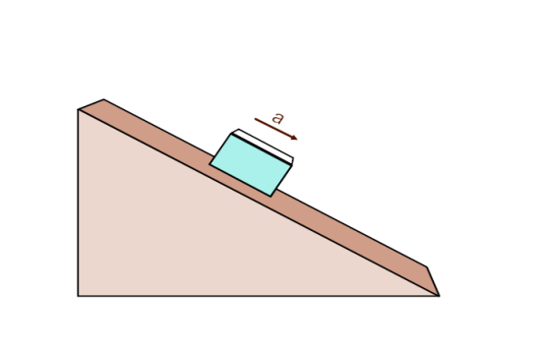

**Classwork**

1. The above box of mass 26 kg is sliding down a frictionless incline that makes an angle of 270 with the horizontal.
   1. Draw the free body diagram showing all forces.
   2. Resolve the gravitational force into its x and y components along the rotated coordinate system.
   3. Find the value of the Normal force.
   4. What is the acceleration of the box?
2. The above box of mass 26 kg is now sliding down a rough surfaced incline that makes an angle of 270 with the horizontal. The coefficient of kinetic friction between the box and the surface is 0.36.
   1. Draw the free body diagram showing all forces.
   2. Resolve the gravitational force into its x and y components along the rotated coordinate system.
   3. Find the value of the Normal force and the kinetic friction force.
   4. What is the acceleration of the box?
3. Compare the acceleration of the box on the two surfaces. Which has the greatest acceleration? Why? 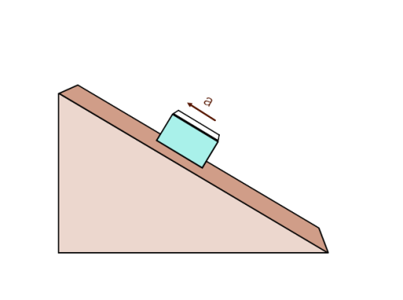
4. The above box of mass 38 kg is being pulled up a frictionless incline, with an applied force of 410 N, which makes an angle of 350 with the horizontal.
   1. Draw the free body diagram showing all forces.
   2. Resolve the gravitational force into its x and y components along the rotated coordinate system.
   3. Find the value of the Normal force.
   4. What is the acceleration of the box?
5. The above box of mass 38 kg is being pulled up a rough surfaced incline, with an applied force of 410 N, which makes an angle of 350 with the horizontal. The coefficient of kinetic friction between the box and the surface is 0.29.
   1. Draw the free body diagram showing all forces.
   2. Resolve the gravitational force into its x and y components along the rotated coordinate system.
   3. Find the value of the Normal force and the kinetic friction force.
   4. What is the acceleration of the box?
6. Compare the acceleration of the box on the two surfaces. Which has the greatest acceleration? Why?
7. A 12 kg box is sliding down an incline where the coefficient of kinetic friction between the box and the incline is 0.11. Find the angle of the incline where the box slides down with a constant velocity.
8. An 8.6 kg box is sitting on a horizontal board. The coefficient of static friction between the board and the box is 0.46. The coefficient of kinetic friction is 0.32. The board is slowly rotated, with one end fixed to the ground, and the box at the end that is being raised into the air.
   1. At what angle will the box start accelerating down the incline?
   2. Once the box is moving, what is its acceleration?

**Homework**



1. The above box of mass 47 kg is sliding down a frictionless incline that makes an angle of 340 with the horizontal.
   1. Draw the free body diagram showing all forces.
   2. Resolve the gravitational force into its x and y components along the rotated coordinate system.
   3. Find the value of the Normal force.
   4. What is the acceleration of the box?
2. The above box of mass 47 kg is now sliding down a rough surfaced incline that makes an angle of 340 with the horizontal. The coefficient of kinetic friction between the box and the surface is 0.28.
   1. Draw the free body diagram showing all forces.
   2. Resolve the gravitational force into its x and y components along the rotated coordinate system.
   3. Find the value of the Normal force and the kinetic friction force.
   4. What is the acceleration of the box?
3. Compare the acceleration of the box on the two surfaces. Which has the greatest acceleration? Why? 
4. The above box of mass 29 kg is being pulled up a frictionless incline, with an applied force of 370 N, which makes an angle of 420 with the horizontal.
   1. Draw the free body diagram showing all forces.
   2. Resolve the gravitational force into its x and y components along the rotated coordinate system.
   3. Find the value of the Normal force.
   4. What is the acceleration of the box?
5. The above box of mass 29 kg is being pulled up a rough surfaced incline, with an applied force of 370 N, which makes an angle of 420 with the horizontal. The coefficient of kinetic friction between the box and the surface is 0.21.
   1. Draw the free body diagram showing all forces.
   2. Resolve the gravitational force into its x and y components along the rotated coordinate system.
   3. Find the value of the Normal force and the kinetic friction force.
   4. What is the acceleration of the box?
6. Compare the acceleration of the box on the two surfaces. Which has the greatest acceleration? Why?
7. A 19 kg box is sliding down an incline where the coefficient of kinetic friction between the box and the incline is 0.15. Find the angle of the incline where the box slides down with a constant velocity.
8. A 4.5 kg box is sitting on a horizontal board. The coefficient of static friction between the board and the box is 0.39. The coefficient of kinetic friction is 0.22. The board is slowly rotated, with one end fixed to the ground, and the box at the end that is being raised into the air.
   1. At what angle will the box start accelerating down the incline?
   2. Once the box is moving, what is its acceleration?
9. **Static Equilibrium – Tension Force**

**Classwork**

1. A box of mass 65 kg is suspended from a massless rope. What is the tension in the rope?
2. A box of mass 32 kg is suspended from a massless rope. The rope is pulled upwards with an acceleration of 2.0 m/s2. What is the tension in the rope?
3. As shown below, a system of two blocks of masses A = 3.2 kg and B = 5.2 kg is accelerated by an applied force of 15 N to the right on a frictionless horizontal surface.
   1. Draw a free body diagram for each block.
   2. Find the acceleration of the system.
   3. Find the tension in the rope connecting the blocks.
4. An engine block of mass 310 kg is supported by two (assume massless) chains. The first chain is at an angle of 550 with respect to the vertical, and the second chain is at an angle of 350 with respect to the vertical. Find the tension in each chain.
5. A light fixture of 5.2 kg is held to the ceiling by two massless cords. Both cords make an angle of 450 to the vertical. Find the tension in each cord.

**Homework**

1. A box of mass 28 kg is suspended from a massless rope. What is the tension in the rope?
2. A box of mass 9.5 kg is suspended from a massless rope. The rope is pulled upwards with an acceleration of 3.0 m/s2. What is the tension in the rope?
3. As shown below, a system of two blocks of masses A = 4.5 kg and B = 6.7 kg is accelerated by an applied force of 19 N to the right on a frictionless horizontal surface.
   1. Draw a free body diagram for each block.
   2. Find the acceleration of the system.
   3. Find the tension in the rope connecting the blocks.
4. A dining room chair of mass 38 kg is supported by two (assume massless) ropes. The first rope is at an angle of 490 with respect to the vertical, and the second rope is at an angle of 410 with respect to the vertical. Find the tension in each rope.
5. A light fixture of 6.8 kg is held to the ceiling by two massless lengths of chain link. The chain on the left makes an angle of 620  with the vertical. The other chain makes an angle of 390 with the vertical. Find the tension in each chain.

**VI. General Problems**

1. A 2.0 kg block slides down a frictionless incline at an angle of 250.
   1. Draw the free body diagram.
   2. Find its acceleration.
2. A 2.0 kg block slides down a rough surfaced incline at an angle of 250 with a constant speed.
   1. Draw a free body diagram.
   2. Find the coefficient of kinetic friction between the block and the incline.
3. A 2.0 kg block remains stationary on an incline. The coefficients of static and kinetic friction are 0.15 and 0.10.
   1. Draw a free body diagram.
   2. Determine the angle that the block will start to move.
4. A 2.0 kg block is pulled up an incline at an angle of 250 at a constant velocity. The coefficient of kinetic friction between the block and the incline is 0.15.
   1. Draw a free body diagram.
   2. Find the applied force.
5. A 2.0 kg block accelerates up an incline at an angle of 250 at a rate of 0.50 m/s2. The coefficient of kinetic friction between the block and the incline is 0.15.
   1. Draw a free body diagram.
   2. Find the applied force.
6. A 0.30 kg block slides down a rough surfaced incline at an angle of 120 with a constant speed.
   1. Draw a free body diagram.
   2. Find the coefficient of kinetic friction between the block and the incline.
7. Two blocks with masses m1 and m2, respectively, are connected by a light string, as shown below. Block 1 is placed on an inclined plane which makes an angle θ with the horizontal. Block 2 is suspended from a pulley that is attached to the top on the inclined plane. The coefficient of kinetic friction between block 1 and the incline is µk.
8. 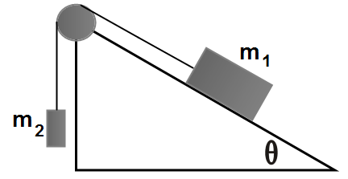Block 1 moves up the inclined plane with a constant velocity v. On the diagram below show all the applied forces on each block.
9. Determine the mass of block 2 that allows block 1 to move up the incline with a constant speed.
10. Determine the mass of block 2 that will cause block 1 to accelerate up the incline at a constant rate a.
11. The string between the blocks is cut. Determine the acceleration of block 1.

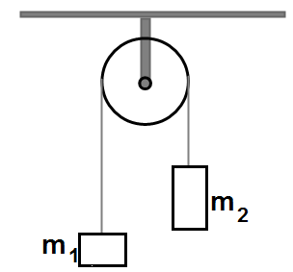

1. In the above diagram, two masses m1 = 400.0 g and m2 = 600.0 g are connected with a light string which goes over a frictionless pulley of negligible mass. The system of two masses is released from rest.
2. Calculate the acceleration of each mass.
3. Calculate the tension force in the string.
4. Calculate the support force in the pivot of the pulley.

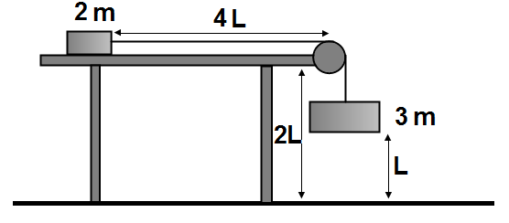

1. In the system presented on the above diagram, block 2m and block 3m are connected by a light string passing over a frictionless pulley. Block 2m is placed on the surface of a horizontal table with negligible friction. Present all answers in terms of m, L, and fundamental constants.
   1. Determine the acceleration of the system after it is released from rest.
   2. Determine the velocity of the 3m block just before it hits the floor.
   3. Determine the velocity of the 2m block at the edge of the table.
   4. Determine the distance between the blocks after they have landed on the floor.
2. Block M1 is connected to block M2 by a light string that passes over a frictionless pulley as shown below. Block M1 is placed on a rough horizontal table. The coefficients of static and kinetic friction between the surface and block M1 are µs and µk respectively.
   1. On the diagram, show all the applied forces on each block.
   2. Determine the minimum value of the coefficient of static friction which will prevent the blocks from moving.
   3. An extra mass Δm is placed on top of block M2. The extra mass causes the system of two blocks to accelerate.
      1. Determine the acceleration of the system.
      2. Determine the tension force in the string.

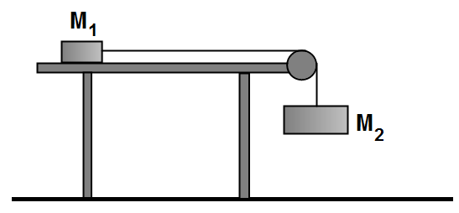

1. A railroad wagon accelerates from rest as shown below. A small metallic sphere of mass m is suspended at the end of a light string which attached to the wagon’s ceiling and makes an angle θ with the vertical.
   1. On the diagram to the right of the wagon, draw a free body diagram of the forces acting on the sphere.
   2. The wagon accelerates for a total of 30.0 s and reaches a velocity of 15 m/s.
      1. Determine the acceleration of the wagon.
      2. Determine the angle θ between the string and the vertical during the wagon’s acceleration.

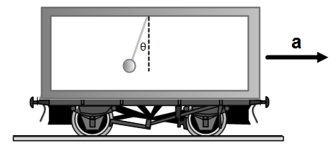

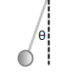

1. An 80.0 kg passenger stands on a measuring scale in an elevator. The scale reading for the first 20.0 s are presented by the graph below. Use g = 10 m/s2 in the following calculations.
   1. Calculate the acceleration of the elevator for the following time intervals: 0-5 s; 5-10 s; 10-15 s; 15-20 s.
   2. Calculate the velocity of the elevator at the end of the following time intervals: 0-5 s; 5-10 s; 10-15 s; 15-20 s.
   3. Calculate the displacement of the elevator from the starting point to the end of the following time intervals: 0-5 s; 5-10 s; 10-15 s; 15-20 s.
   4. Draw the following graphs: a(t), v(t), x(t).

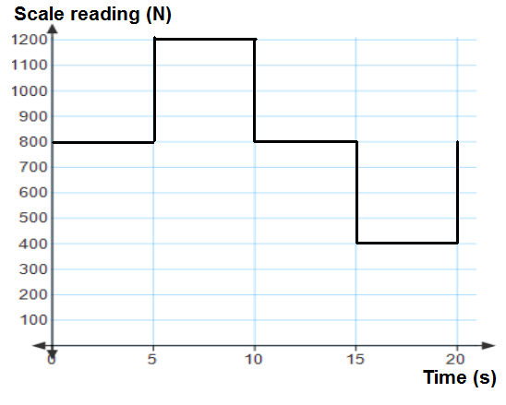

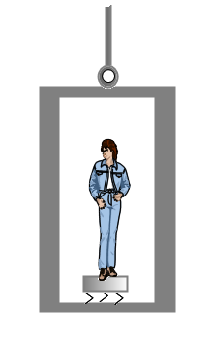

1. A piano is stuck in a bed of gravel. Fortunately there is a sturdy metal post located nearby and a rope is wrapped around the pole and the other end is tied off to the piano. It will take 970 N to move the piano. The piano starts moving (assume a = 0 m/s2) when the angle below is 6.00. What force is applied by the person pushing on the rope at the point indicated by the arrow?

**Answers**

**Chapter Questions**

1. An object maintains its velocity (both speed and direction) unless acted upon by a non-zero net force.
2. Yes. If there is a zero net force, there is no acceleration. So, an object can be moving at a constant velocity without an applied force.
3. It depends. Assume the positive direction of displacement, velocity and acceleration is to the right. An object moving to the right with increasing velocity has a positive acceleration. An object moving to the right with decreasing velocity has a negative acceleration. An object moving to the left with increasing negative velocity has a negative acceleration. An object moving to the left with decreasing negative velocity has a positive acceleration. Velocity tells you how the displacement is changing (which way it is moving). Acceleration it tells you how the velocity is changing – and is not always in the same direction of the displacement.
4. The table pushes up on the box, and the box pushes down on the table. The earth’s gravitational field attracts the box and the box’s gravitational field attracts the earth. The earth’s gravitational field attracts the table and the table’s gravitational field attracts the earth.
5. Since the ball is accelerating without a net non-zero external force, it is not in an inertial reference frame. In this case, the train is accelerating forward, and the ball remains stationary in the inertial reference frame of the train tracks. Relative to observers in the train, the ball is moving. Relative to an observer standing next to the tracks, it is not moving.
6. Mass is a fundamental quantity and measures the amount of material in an object in kilograms. Weight is the effect of a gravitational field on a mass and is measured in Newtons – it is a force.
7. The normal force is a contact force and is the reaction of an object to a force being applied to it. It is always perpendicular to the surface.
8. Kinetic friction is a force that opposes motion. Static friction is a force that acts on an object to resist the initiation of motion by an applied force. For a given interaction between two types of materials, static friction will increase with the applied force until it reaches a maximum value and the objects begin to move relative to each other. Kinetic friction is a constant and is less than the maximum value of static friction.
9. A free body diagram is a drawing that shows all the forces acting on an object. Once the forces are drawn, and an expected direction of the object’s acceleration is shown, then Newton’s Second and Third Laws are used to find its acceleration.
10. That will enable the Normal force to be found, which is used to calculate the frictional forces.
11. The object is moving smoothly in the x axis, and has no component of motion in the y direction (it is not bouncing).
12. Wagon being pulled by F:
    1. Resolve F into its x component (Fx = Fcosθ) and apply Newton’s Second Law.
    2. Resolve F into its y component (Fy = Fsinθ). Use the free body diagram, assume that the wagon is not bouncing and set ΣFy = 0. This enables FN to be found which is used to calculate the frictional force.
    3. The frictional force is greater when the wagon is being pushed, since FN is greater.
13. Object moving with a constant velocity:
    1. Directly down.
    2. Perpendicular to the surface of the plane.
    3. The component of the gravitational force parallel to the surface of the inclined plane.
14. It is convenient to have the direction of the acceleration aligned with the coordinate system. Also, this will typically result in resolving fewer force vectors into their perpendicular components – reduces the amount of trigonometry needed.
15. The net force must be zero in both x and y directions (and the z direction when three dimensions are considered).
16. Box suspended from the ceiling:
    1. Equal.
    2. The more vertical rope has the greater tension.
    3. A vertical upward force must be exerted by the support ropes to balance the weight of the box. The only way this can occur is if the ropes have a vertical component of their position.

**Chapter Problems**

1. 2a/3
2. 0.6 a
3. 18 F
4. m/16
5. 510 N; 510 N
6. 3200 N
7. 118 N
8. 80 N
9. No. The maximum static friction force is 485 N.
10. The maximum fk is 485 N, so the couch will move. Fk = 323 N. Fnet = (525-323)N = 202N. a=1.3 m/s2
11. 3a/8
12. 3.5 a
13. 18 F
14. m/27
15. 440 N; 440 N
16. 4500 N
17. 160 N
18. 49 N
19. No. The maximum static friction force is 590 N, so an applied force of 500 N will be met with an opposing frictional force of 500 N, so ΣF=0 and a=0.
20. 1.4 m/s2
21. Fx (N) Fy (N)
    1. 38 55
    2. 65 45
    3. 6.5 24
    4. 38 1.0
22. Fx (N) Fy (N)
    1. 58 -58
    2. -24 -11
    3. -42 11
    4. -36 51
23. Fx (N) Fy (N)
    1. 72 69
    2. -14 30
    3. -25 -15
    4. 58 -58
24. Fx (N) Fy (N)
    1. 18 34
    2. -10 11
    3. -77 -43
    4. 29 -32
    5. 240 N
    6. 14 m/s2
    7. 2100 N
    8. 9.5 m/s2
    9. Fx=320N;Fy=250N
    10. FN=190N;less than;reduces
    11. 6.4m/s2
    13. Fx=320N;Fy=-250N
    14. 690N;more than;increases
    15. 4.4m/s2
25. The pulled wagon has the greater acceleration; it has a smaller Normal force which results in a smaller kinetic friction force opposing the applied force.

    2. 380N
    3. 14m/s2
    5. 2400N
    6. 13m/s2
    8. Fx=310N;Fy=320N
    9. 92N
    10. 6.9m/s2
    12. Fx=310N;Fy=-320N
    13. 730N
    14. 3.7m/s2
26. The pulled wagon has the greater acceleration; it has a smaller Normal force which results in a smaller kinetic friction force opposing the applied force.

    2. Fx=120N;Fy=230N
    3. 230N
    4. 4.6m/s2
    6. Fx=120N;Fy=230N
    7. FN=230N;fk=83N
    8. 1.4m/s2
27. The box without the friction has a greater acceleration as there is no force opposing the x component of the gravitational force.

    2. Fx=210N;Fy=300N
    3. 300N
    4. 5.3m/s2
    6. Fx=210N;Fy=300N
    7. 300N
    8. 3.0m/s2
28. The box without the friction has a greater acceleration as there is no force opposing the x component of the gravitational force.
29. 6.30
30. a) 250 b) 1.3m/s2

    2. Fx=260N;Fy=380N
    3. 380N
    4. 5.5m/s2
    6. Fx=260N;Fy=380N
    7. FN=380N;fk=110N
    8. 3.2m/s2
31. The box without the friction has a greater acceleration as there is no force opposing the x component of the gravitational force.

    2. Fx=190N;Fy=210N
    3. 210N
    4. 6.2m/s2
    6. Fx=190N;Fy=210N
    7. FN=210N;fk=44N
    8. 4.7m/s2
32. The box without the friction has a greater acceleration as there is no force opposing the x component of the gravitational force.
33. 8.50
34. a) 210 b) 1.5m/s2
35. 640N
36. 380N

    2. 1.8m/s2
    3. 5.8N
37. T1=1700N;T2=2500N
38. 36N
39. 270N
40. 120N

    2. 1.7m/s2
    3. 7.7N
41. T1=240N;T2=280N
42. T1=43N;T2=60N

**General Problems**

1. 1. 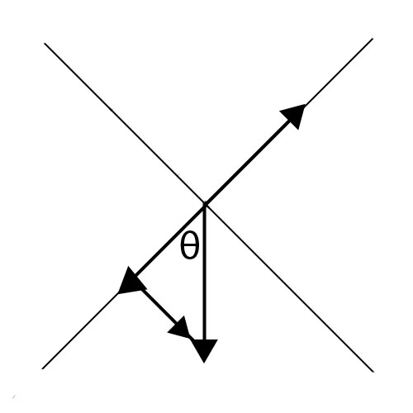

mg

mg cosθ

mg sinθ

FN

* 1. a = 4.1 m/s2
  2. 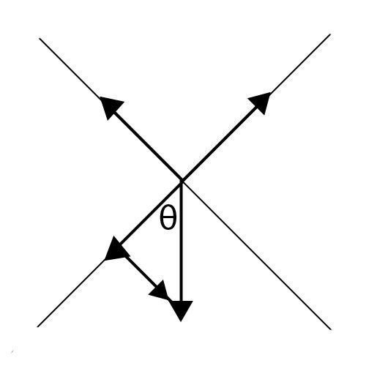

mg

f

mg sinθ

mg cosθ

FN

* 1. μ = 0.47

1. 1. 

FN

mg

mg sinθ

mg cosθ

fs

* 1. θ= 8.5O
  2. 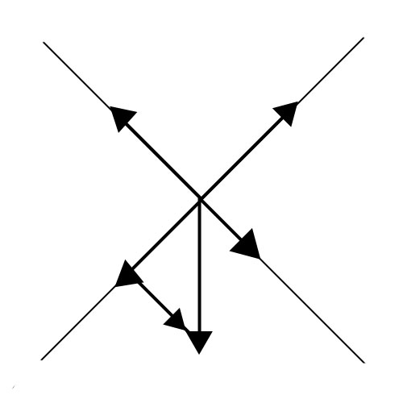

FK

Fapp

FN

mg

mg sinθ

mg cosθ

* 1. Fapp = 11 N

1. 1. 

FK

Fapp

FN

mg

mg sinθ

mg cosθ

* 1. Fapp = 12 N
  2. 

mg

f

mg sinθ

mg cosθ

FN

* 1. μ= 0.21

1. 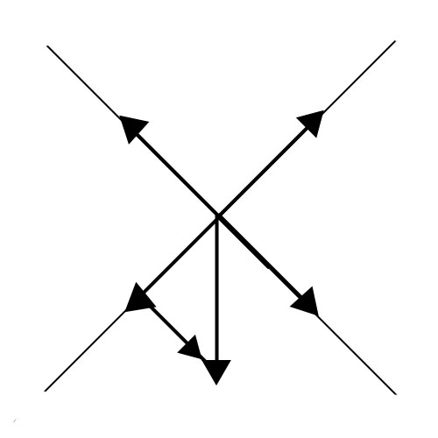
   1. 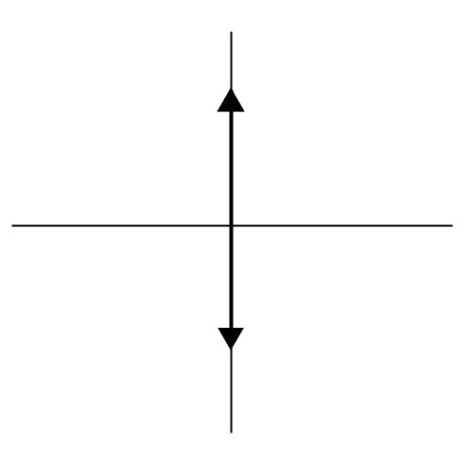

m1gsinθ

m1gcosθ

FK

FN

FT

m2g

m1g

FT

* 1. m2 = m1 (sinθ + μ cosθ)
  2. m2
  3. a = g sin θ – g cos θ  
     or  
     a = g (sin θ – cos θ)

1. 1. a = 2.0 m/s2
   2. T = 4.7 N
   3. FSUPP = 9.4 N
2. 1. a = 3/5 g
   2. v =
   3. v =
   4. x =
3. 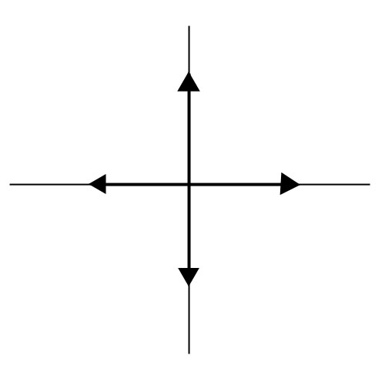  
     
   

M2g

M1g

Fs

FT

FN

FT

* 2. μs = M2/M1
  4. FT = M1g (µ+ )

1. 1. 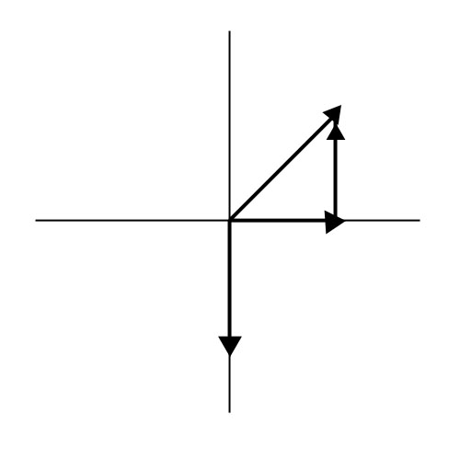

T

T sinθ

T cosθ

mg

* 1. a = .5 m/s2
  2. θ= 2.9O

1. 1. a(0-5s) = 0 m/s2, a(5-10s) = 5 m/s2, a(10-15s) = 0 m/s2, a(15-20s) =-5 m/s2
   2. v(0-5s) = 0 m/s, v(5-10s) = 25 m/s, v(10-15s) = 25 m/s, v(15-20s) =0 m/s
   3. x(0-5s) = 0 m, x(5-10s) = 62.5 m, x(10-15s) = 187.5 m, x(15-20s) =250 m
   4. 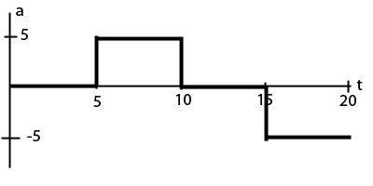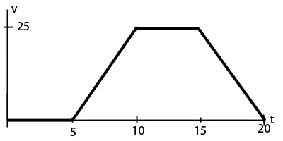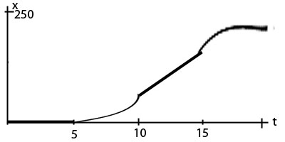
2. 2FTsin(60)=FP=200N