Name________________________________________Class__________Date_______

Raw Score __________ Percentage __________

**Unit 3: Mansa Musa**

Writing a Document-Based Essay Part B

**DIRECTIONS**

Write an essay about how Mansa Musa changed people’s views of West Africa. Include an introduction, a body of several paragraphs, and a concluding paragraph. Using at least ***three*** of the sources in Part A, provide facts and details that support your response. You may draw on any additional knowledge you have acquired about the subject.

**HISTORICAL CONTEXT**

Mansa Musa, the ruler of Mali from 1312-1337, was one of the Muslim kings of West Africa. He became a major figure in African and world history largely because of a pilgrimage he made to the city of Mecca. His spectacular journey attracted the attention of the Muslim world and Europe. For the first time, other people’s eyes turned to West Africa.

**TASK**

Use evidence from three of the four documents to explain how Mansa Musa changed people’s views of West Africa.

**GUIDELINES**

• Provide a thorough response to the Task. Be sure to cover all parts of the

assignment.

• Use at least ***three*** of the sources in Part A and include specific information from

them in your essay.

• Take advantage of relevant information you remember from your textbook and

class work.

• Organize your essay in a clear and logical way.

• Support your statements with facts and information that address the topic.

• Write a conclusion that sums up your ideas.

NOTE: Do not simply restate the Task or Historical Context. Your essay should

include much more information.

**Document 1: Hajj by the Numbers**

**Source:** Chart compiled from various sources.

**Note:** Many of these numbers are rough estimates drawn from oral history and a few written records.

|  |  |
| --- | --- |
| **Mansa Musa’s Hajj by the Numbers** | |
| Number of people on the hajj | 60,000 |
| Number of slaves who were Mansa Musa’s personal servants | 12,000 |
| Number of slaves who carried gold | 500 |
| Number of miles traveled from Niani to Mecca | 4,000 |
| Time it took to cross Mali on a donkey | 4 months |
| Number of camels | 1,000 |
| Number of camels to carry gold | 80-100 |
| Amount of gold on each camel | 100-300 pounds |
| Distance a camel can travel without water | 100 miles |
| Distance a loaded camel can travel in a day | 20-25 miles |
| Total amount of gold (for alms giving, gifts, salaries, supplies) | 24,000 pounds |
| People in the caravan | musicians,  royal guards,  flag bearers,  doctors,  teachers |

**Hajj by the Numbers Document Analysis**

1. What percentage of travelers on the *hajj* were Mansa Musa's personal servants?

2. Why are you going on this journey? What possible benefits may result?

*3.* What information might worry you about traveling on the *hajj?*

4. Which of the numbers in this chart might be exaggerations? Explain your thinking.

# Document 2: Catalan Atlas

*The Catalan Atlas is a medieval map from Spain drawn in 1375 by a mapmaker named Abraham Cresques. Cresques had never visited West Africa but relied on the accounts of travelers and traders to make his map.*

''Through this place pass the merchants who travel to the land of (Mali):'

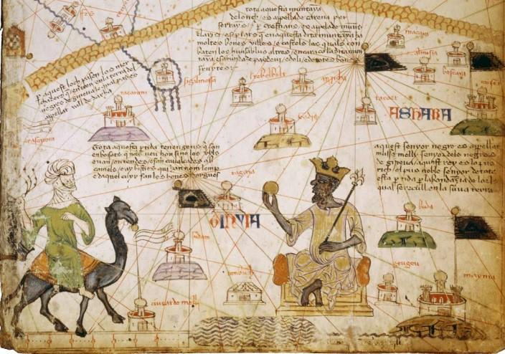

''This Negro lord is called Musa Mali, lord of all the Negroes of (the region of Mali). So abun· dant is the gold which is found in his country that he is the richest and most noble king in all the **land."**

“This Black lord is called Musa Mali, Lord of the Black people of Mali. So abundant is the gold which is found in his country that he is the richest and most noble king in all the land.”—*Catalan Atlas inscription*

"All this region is occupied by people who veil their mouths; one only sees their eyes. They live in tents and have caravans of camels. There are also beasts called Lemp from the skins of which they make fine shields."

***Source:*** *Abraham Cresques, 1375.*

### Catalan Atlas: Guiding Questions

1. (Sourcing) What kind of document is this? Who created it? When?
2. (Corroboration) How does the Catalan Atlas compare to *The Huffington Post* blog post in terms of its depiction of Mansa Musa?
3. Do you think this is an accurate depiction of Mansa Musa? Why or why not?

# Document 3: Al-Umari

*Al-Umari was an Arab historian from Damascus, Syria. He visited the city of Cairo in Egypt several years after Mansa Musa passed through there on his pilgrimage in 1324 CE. He then wrote this account of Mansa Musa’s visit, as told to him by the people of Cairo.*

From the beginning of my coming to stay in Egypt I heard talk of the arrival of this **sultan** Musa on his Pilgrimage and found the people of Cairo eager to tell what they had seen of the Africans’ extravagant spending. I asked the **emir** Abu and he told me of the **opulence**, manly virtues, and **piety** of his sultan. Abu said, “When I went out to meet him, Musa did me extreme honor and treated me with the greatest courtesy. He addressed me, however, only through an interpreter despite his perfect ability to speak in the Arabic tongue. Then he sent to the royal treasury many loads of unworked native gold and other valuables. I tried to persuade him to go up to the Citadel to meet the sultan of Cairo, but he refused persistently saying: ‘I came for the Pilgrimage and nothing else. I do not wish to mix anything else with my Pilgrimage.’”

Mansa Musa flooded Cairo with his gifts. He left no emir or holder of a royal office without the gift of a load of gold. The people of Cairo made **incalculable** profits out of him and his caravan in buying and selling and giving and taking. They traded away gold until they **depressed** its value in Egypt and caused its price to fall. This has been the state of affairs for about twelve years until this day by reason of the large amount of gold which they brought into Egypt and spent there.

***Source:*** *Al-Umari,* Pathways of Vision in the Realms of the Metropolises, *1337-1338.*

### Vocabulary

sultan: king

emir**:** a high ranking title

opulence**:** great wealth, especially shown by extravagant living

piety**:** religious devotion incalculable**:** huge depressed**:** lowered

**Al-Umari: Guiding Questions**

1. (Sourcing) Who is Al-Umari? Do you think he is a reliable source of information on Mansa Musa’s pilgrimage to Mecca? Why, or why not?
2. (Corroboration) How does this document compare to *The Huffington Post* blog post and the Catalan Atlas in terms of its depiction of Mansa Musa?
3. (Close Reading) How does the emir Abu describe Mansa Musa to Al-Umari? According to the emir Abu, what traits does Mansa Musa possess?
4. Do you think Al-Umari’s description of Mansa Musa is accurate? Why or why not?

**Document 4: Qur’an**

**Source:** Verses from the Qur'an, the Muslim holy book. Translated by N.J. Dawood.

**Note:** Although Mansa Musa was a Muslim, he did not require his citizens to be Muslims. Most historians believe this was because many people in the empire still practiced traditional African religions; Islam was the religion of traders and the court. Many of the slaves and soldiers on the trip were likely not Muslim and would not have made the final trek from Cairo to Mecca. For Mansa Musa, however, the verses below would have had great meaning.

Give generously for the cause of God and do not with your own hands cast yourselves into destruction. Be chari­table. God loves the charitable. **2:195**

Make the pilgrimage [hajj] and visit the Sacred House for His sake. If you cannot, send such offerings as you can afford and do not shave your heads until the offerings have reached their destination...**2:196**

Make the pilgrimage in the appointed months. He that intends to perform it in those months must abstain from...obscene language, and acrimonious [angry]disputes while on pilgrimage. God is aware of whatever good you do. Provide well for yourselves: the best provision is piety [devotion to faith]. Fear Me, then, you that are endowed with understanding.

**2:197**

To be charitable in public is good, but to give alms [gifts of charity] to the poor in private is better and will atone for some of your sins. God has knowledge of all your actions. **2:271**

Those that give alms by night and by day, in private and in public, shall be rewarded by their Lord. They shall have nothing to fear or to regret. **2:274**

**Document Analysis: Qur’an**

1. According to the verses, why must the *hajj* be completed? Whom are the pilgrims looking to please?

2*.* What type of personal behavior is expected on the *hajj?*

3. According to the verses, why should Muslims give alms?

4. What does verse 2:271 suggest about those who give alms publicly?

5. We know from Document A that Mansa Musa was carrying great quantities of gold. Do these lines from the Qur'an suggest what that gold might be used for?